 | Rob Knudsen  Project Affairs Manager  8330 Century Park Court, CP31D  San Diego, CA 92123  Rknudse1@sdge.com
September 11, 2026
Dear Resident or Property Owner:
San Diego Gas and Electric (SDG&E®) is committed to providing safe and reliable energy. To do this, we will make improvements to our electrical system. The Coronado Island Reliability Reinforcement Project is a California Independent System Operator (CAISO) approved project to support forecasted load growth on Coronado Island. We will be upgrading two existing electric transmission sources that serve the Island and constructing a new third source from downtown San Diego to Coronado. This work is necessary to ensure that the reliability of our electric transmission systems meet current engineering standards, accommodate load growth, and to improve system safety and efficiency in SDG&E’s service territory. The project will achieve the objectives of providing additional capacity to serve existing area load with future customer-driven electrical growth and enhance the transmission and power network to minimize the potential for long-term unplanned outages or service disruptions to area residents and businesses.

SDG&E will begin this phase of the project by performing underground civil work to trench and install new underground transmission facilities in the City of Coronado public streets; we anticipate starting in approximately late September 2026. This scope of work will occur on 1st Street from approximately B to E Avenue. Work will continue south on E Avenue to 2nd Street and on 2nd Street west to Alameda Boulevard turning north ending near an existing substation near Alameda Boulevard and 1st Street. Some public parking and sidewalk access may be unavailable during this phase of the project, as permitted by the City of Coronado to allow for safe construction access while reducing traffic congestion.

Location: City of Coronado streets including 1st St., E Ave., 2nd St., and Alameda Blvd. as described above; select work on Naval Amphibious Base Coronado.
Work Days: Monday to Friday 7:00am – 6:00pm
Start Date: Approximately late September 2026
Duration: About 12 months
*Dates and times are subject to change according to compliance requirements, inclement weather and other unforeseen circumstances

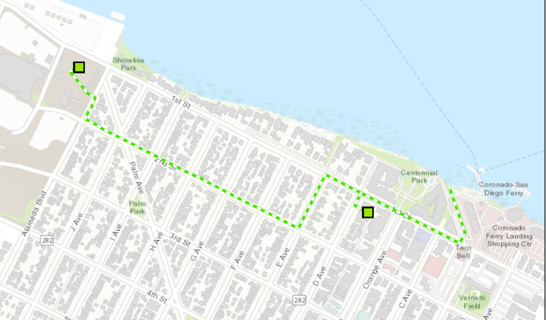

SDG&E will work closely with local municipalities and community groups to ensure construction activities are as least disruptive as possible. Modest noise, dust, and traffic/parking disturbances may increase due to construction activities. We do not anticipate significant trenching for the reconductor of the existing power lines, only for the new power line that we will install. We will keep communities informed during all phases of the project. We’re committed to working with you and local public safety officials to help reduce inconveniences and safeguard a smooth construction process.

To learn more about this reliability project, please see the attached project fact sheet or visit sdge.com/major-projects.

If you have any questions or require additional information please call (844)765-6388.

Sincerely,

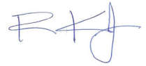
Rob Knudsen
Project Affairs Manager
San Diego Gas & Electric Company

