7
Application No: A.08-02-
Exhibit No.:
Witness: David M. Bisi

In the Matter of the Application of San Diego Gas & Electric Company (U 902 G) and Southern California Gas Company (U 904 G) for Authority to Revise Their Rates Effective January 1, 2009, in Their Biennial Cost Allocation Proceeding. | )  )  )  )  )  )  ) | A.08-02-___  (Filed February 4, 2008)
PREPARED DIRECT TESTIMONY
OF DAVID M. BISI
SAN DIEGO GAS & ELECTRIC COMPANY
AND
SOUTHERN CALIFORNIA GAS COMPANY

BEFORE THE PUBLIC UTILITIES COMMISSION
OF THE STATE OF CALIFORNIA
February 4, 2008

TABLE OF CONTENTS
Page
I. QUALIFICATIONS 1
II. PURPOSE 1
III. SOCALGAS TRANSMISSION SYSTEM 1
IV. SDG&E GAS TRANSMISSION SYSTEM 2
V. DESIGN CRITERIA AND SYSTEM CAPACITY 3
VI. BACKBONE TRANSMISSION RESERVE MARGIN 4
VII. DEMAND FORECASTS AND GAS RESOURCE PLAN 6

PREPARED DIRECT TESTIMONY
OF DAVID M. BISI

I. QUALIFICATIONS
My name is David M. Bisi. I am employed by Southern California Gas Company (SoCalGas) as a Project Manager in the Gas Transmission Planning Department. My business address is 555 West Fifth Street, Los Angeles, California, 90013-1011.
I received a Bachelor of Science degree in Mechanical Engineering from the University of California at Irvine in 1989. I have been employed by SoCalGas since 1989, and have held positions within the Engineering, Customer Services, and Gas Transmission departments.
I have held my current position since April, 2002. My current responsibilities include the management of the Gas Transmission Planning Department responsible for the design and planning of SoCalGas’ and San Diego Gas & Electric Company’s (SDG&E’s) gas transmission and storage systems.
I have previously testified before the Commission.

II. PURPOSE
The purpose of my testimony is to present the long-term resource plan for the SoCalGas and SDG&E gas transmission systems for the plan period of 2009 – 2023.

III. SOCALGAS TRANSMISSION SYSTEM
SoCalGas owns and operates an integrated transmission system consisting of pipeline and storage facilities. With its network of transmission pipeline and four interconnected storage fields, SoCalGas delivers natural gas to over five million residential and business customers.
A map of the SoCalGas transmission system is attached as Figure 1. The transmission system extends from the Colorado River on the eastern end of SoCalGas’ 23,000 square mile service territory, to the Pacific Coast on the western end; from Tulare County in the north, to the U.S./Mexico border in the south (excluding parts of San Diego County).
The SoCalGas transmission system was designed to receive and redeliver gas from the east, initially to the load centers in the Los Angeles basin, Imperial Valley, San Joaquin Valley, north coastal areas, and San Diego. As our customers sought to access new supply sources in Canada and the Rockies, we modified our system to concurrently accept deliveries from the north. As a result, the system today can accept up to 3,875 million cubic feet per day (MMcfd) of interstate and local California supplies on a firm basis. Primary supply sources are the southwestern United States, the Rocky Mountain region, Canada, and California on- and off-shore production. The interstate pipelines that supply the SoCalGas transmission system are El Paso Natural Gas Company (El Paso), Transwestern Pipeline Company (Transwestern), Kern River Gas Transmission Company (Kern River), Mojave Pipeline Company (Mojave), Questar Southern Trails Pipeline Company (Southern Trails), and Gas Transmission Northwest via PG&E’s intrastate system (PG&E/GTN). The SoCalGas transmission system interconnects with El Paso at the Colorado River near Needles and Blythe, California, and with Transwestern and Southern Trails near Needles, California. SoCalGas also interconnects with the common Kern/Mojave pipeline at Wheeler Ridge in the San Joaquin Valley and at Kramer Junction in the high desert. At Kern River Station in the San Joaquin Valley, SoCalGas maintains a major interconnect with the PG&E intrastate pipeline system, and receives PG&E/GTN deliveries at that location.
SoCalGas operates four storage fields that interconnect with its transmission system. These storage fields – Aliso Canyon, Honor Rancho, La Goleta, and Playa del Rey – are located near the primary load centers of the SoCalGas system. Together they have a combined inventory capacity of 131.1 billion cubic feet (Bcf), a combined firm injection capacity of 850 MMcfd, and a combined firm withdrawal capacity of 3,195 MMcfd.

IV. SDG&E GAS TRANSMISSION SYSTEM
A schematic of the SDG&E gas transmission system is shown in Figure 2. The SDG&E gas transmission system consists primarily of two high-pressure large diameter pipelines that extend south from Rainbow Station, located in Riverside County. Both pipelines terminate at the SDG&E citygate regulator stations in San Diego.
The pipelines are interconnected approximately at their midpoint and again near their southern terminus. The northern cross-tie runs between Carlsbad and Escondido, with the southern cross-tie running through Miramar.
A large diameter pipeline extends from the cross tie at Miramar to Santee. At Santee, another large diameter pipeline extends to the Otay Mesa meter station at the U.S./Mexico border.
A smaller diameter pipeline, owned by SoCalGas, extends south from the San Onofre metering station in Orange County to La Jolla, and operates at a lower pressure than the rest of the SDG&E gas transmission system.
Two compressor stations are also a part of the SDG&E gas transmission system. SDG&E’s Moreno compressor station, located in Moreno Valley, boosts pressure into the SoCalGas transmission lines serving Rainbow Station. A much smaller compressor station is located at Rainbow Station.

V. DESIGN CRITERIA AND SYSTEM CAPACITY
In D.06-09-039, the Commission established a common design standard for SoCalGas, SDG&E, and PG&E for “slack capacity” or reserve margin on their backbone transmission systems. Per the Order, the utilities are to:

“…plan and maintain intrastate natural gas backbone transmission systems sufficient to serve all system demand on an average day in a one-in-ten cold
and dry-hydroelectric year.” [D.06-09-039, Ordering Paragraph No. 1]

At the time of the Order, SoCalGas had a reserve margin of 11% to 16% relative to this design standard; SDG&E, when viewed as a backbone transmission system, had a reserve margin of 16% to 21% relative to this measure. The Commission adopted this reserve margin range in D.06-09-039
Additionally the Commission upheld the SoCalGas and SDG&E planning standards for their local transmission and storage systems. SoCalGas and SDG&E design their systems to provide service to core customers during a 1-in-35 year cold day condition, under which both firm and interruptible noncore transportation service is curtailed. The systems are also designed to provide for continuous firm noncore transportation service under a 1-in-10 year cold day condition, during which only interruptible noncore transportation service is curtailed. Both design standards are expected to occur during the winter operating season when core customers’ gas usage is the greatest.
The SoCalGas transmission and storage system currently has sufficient capacity to serve a demand of 6.0 billion cubic feet per day (BCFD) through a combination of flowing supply and storage (provided sufficient flowing supply is delivered to the system by our customers). Based on the current winter demand forecast, the SDG&E transmission system currently has sufficient capacity to serve 630 MMcfd of customer demand. This figure for SDG&E system capacity is somewhat less than has previously been provided to the Commission due to the growing demand forecasted in San Diego and Riverside Counties.

VI. BACKBONE TRANSMISSION RESERVE MARGIN
As shown in Tables 1 and 2 below, SoCalGas and SDG&E have a sufficient level of reserve margin throughout the plan period without the need for additional facilities or improvements:

Table 1
SoCalGas Reserve Margin
One- in-Ten Year Cold and Dry-Hydroelectric Condition
Year | Annual Average Daily Demand (MMcfd) | Reserve Margin
2009 | 2,642 | 47%
2010 | 2,639 | 47%
2011 | 2,624 | 48%
2012 | 2,630 | 47%
2013 | 2,631 | 47%
2014 | 2,632 | 47%
2015 | 2,636 | 47%
2016 | 2,640 | 47%
2017 | 2,666 | 45%
2018 | 2,662 | 46%
2019 | 2,671 | 45%
2020 | 2,677 | 45%
2021 | 2,721 | 42%
2022 | 2,786 | 39%
2023 | 2,797 | 39%
Demand source: 2009 BCAP forecast for years 2009-2011, extended through 2023. Reserve margin relative to existing SoCalGas receipt capacity of 3,875 MMcfd.

Table 2
SDG&E Reserve Margin
One-in-Ten Year Cold and Dry-Hydroelectric Condition
Year | Annual Average Daily Demand (MMcfd) | Reserve Margin
2009 | 355 | 77%
2010 | 365 | 73%
2011 | 336 | 88%
2012 | 336 | 87%
2013 | 337 | 87%
2014 | 334 | 89%
2015 | 332 | 90%
2016 | 332 | 90%
2017 | 335 | 88%
2018 | 336 | 87%
2019 | 338 | 86%
2020 | 339 | 86%
2021 | 346 | 82%
2022 | 353 | 79%
2023 | 360 | 75%
Demand source: 2009 BCAP forecast for years 2009-2011, extended through 2023. Reserve margin relative to current SDG&E system capacity of 630 MMcfd.

VII. DEMAND FORECASTS AND GAS RESOURCE PLAN
The 1-in-35 and 1-in-10 year cold day condition demand forecasts for SoCalGas are presented below in Table 3:

Table 3
SoCalGas Design Criteria Demand Forecast
Year | 1-in-35 Year Cold Day Demand  (MMcfd) |  |  |  |  | 1-in-10 Year Cold Day Demand  (MMcfd)
Year | Core | N/C C&I | EG | Whole-  sale | Total | Core | N/C C&I | EG | Whole-  sale | Total
2009/10 | 3082 | 0 | 0 | 523 | 3605 | 2852 | 460 | 798 | 802 | 4912
2010/11 | 3086 | 0 | 0 | 528 | 3613 | 2856 | 460 | 803 | 793 | 4912
2011/12 | 3089 | 0 | 0 | 532 | 3621 | 2859 | 459 | 768 | 755 | 4841
2012/13 | 3085 | 0 | 0 | 529 | 3615 | 2856 | 443 | 876 | 764 | 4939
2015/16 | 3063 | 0 | 0 | 541 | 3604 | 2836 | 445 | 806 | 767 | 4854
2020/21 | 3030 | 0 | 0 | 558 | 3588 | 2805 | 438 | 1014 | 819 | 5076
2023/24 | 3033 | 0 | 0 | 572 | 3604 | 2809 | 436 | 1115 | 846 | 5206

As shown in Table 3, SoCalGas has sufficient capacity to meet the 1-in-35 year cold day demand forecast through the plan period without additional facilities or improvements. SoCalGas, as a whole, also has sufficient capacity to meet the 1-in-10 year cold day demand forecasts through the plan period. However, two local transmission systems that are currently constrained require additional capacity to meet the 1-in-10 year cold day demand throughout the plan period: San Diego and the San Joaquin Valley. Also note that an expansion in the Imperial Valley is currently underway to meet customer requested levels of firm transportation service in the summer operating season. This expansion is estimated at $40.7 million, and is expected to be in service by 2009. Unlike the SDG&E system or the San Joaquin Valley System, though, the Imperial Valley System is a summer-peaking system. Sufficient capacity exists on the Imperial Valley System even without the planned expansion to meet the 1-in-10 year cold day demand condition through the plan period.
Table 4 below presents the 1-in-35 and 1-in-10 year cold day demand forecasts for SDG&E:

Table 4
SDG&E Design Criteria Demand Forecast
Year | 1-in-35 Year Cold Day Demand  (MMcfd) |  |  |  | 1-in-10 Year Cold Day Demand  (MMcfd)
Year | Core | N/C C&I | Large  EG | Total | Core | N/C C&I | Large  EG | Total
2009/10 | 390 | 0 | 0 | 390 | 365 | 64 | 203 | 632
2010/11 | 391 | 0 | 0 | 391 | 366 | 64 | 190 | 620
2011/12 | 392 | 0 | 0 | 392 | 367 | 64 | 147 | 578
2012/13 | 386 | 0 | 0 | 386 | 361 | 64 | 159 | 584
2015/16 | 387 | 0 | 0 | 387 | 362 | 65 | 153 | 580
2020/21 | 394 | 0 | 0 | 394 | 369 | 68 | 186 | 623
2023/24 | 402 | 0 | 0 | 402 | 376 | 70 | 199 | 645
The SDG&E system has sufficient capacity to meet the 1-in-35 year cold day demand condition throughout the plan period. However, forecasted demand in San Diego under the 1-in-10 year cold day design condition exceeds the system capacity beginning in the 2020/21 operating season. In A.06-10-034, SDG&E and SoCalGas identified a cost-effective means of increasing the capacity of the SDG&E and Rainbow Corridor Systems by receiving a modest level of reliable supply delivered at Otay Mesa. In D.07-05-022, the Commission approved this approach to increasing the capacity of the two systems.
By receiving 50 MMcfd of reliable supply at Otay Mesa, the capacity of the SDG&E system is increased to 650 MMcfd. This level of capacity is forecast to be sufficient through the plan period.
The 1-in-35 and 1-in-10 year cold day condition demand forecasts for the San Joaquin Valley are presented below in Table 5:

Table 5
San Joaquin Valley Design Criteria Demand Forecast
Year | 1-in-35 Year Cold Day Demand  (MMcfd) |  |  |  | 1-in-10 Year Cold Day Demand  (MMcfd)
Year | Core | N/C C&I | EG | Total | Core | N/C C&I | EG | Total
2009/10 | 121 | 0 | 0 | 121 | 116 | 42 | 0 | 158
2010/11 | 124 | 0 | 0 | 124 | 119 | 42 | 0 | 161
2011/12 | 127 | 0 | 0 | 127 | 122 | 42 | 0 | 164
2012/13 | 130 | 0 | 0 | 130 | 125 | 42 | 0 | 167
2015/16 | 140 | 0 | 0 | 140 | 135 | 42 | 0 | 177
2020/21 | 159 | 0 | 0 | 159 | 153 | 42 | 0 | 195
2023/24 | 171 | 0 | 0 | 171 | 165 | 42 | 0 | 207

The existing capacity of the San Joaquin Valley System is 180 MMcfd. Sufficient capacity exists to meet forecasted demand under the 1-in-35 year cold day demand scenario throughout the plan period. However, forecasted demand under the 1-in-10 year cold day design standard begins to exceed system capacity between 2015 and 2020.
SoCalGas has identified that 3200 HP of compression at Avenal and 8 miles of 36-inch diameter looping along its Transmission Line 7000 in the San Joaquin Valley will increase the capacity of the San Joaquin Valley System to 217 MMcfd, sufficient to meet the forecasted level of 1-in-10 year cold day demand through the plan period. The estimated cost for this new compression and pipeline looping is $50.7 million.
This concludes my testimony.
FIGURE 1
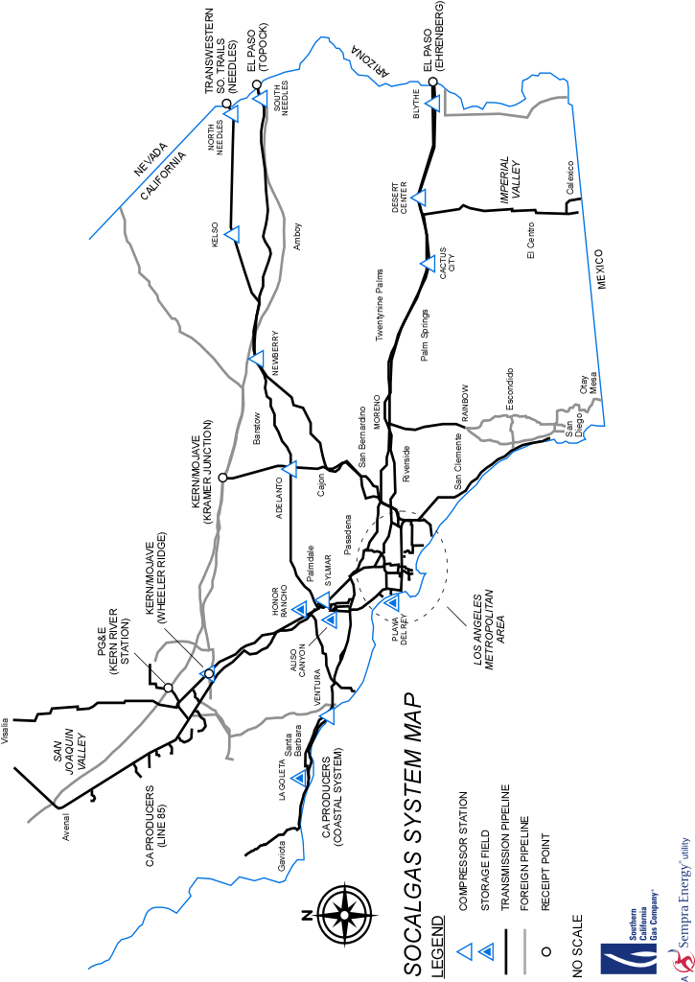
FIGURE 2
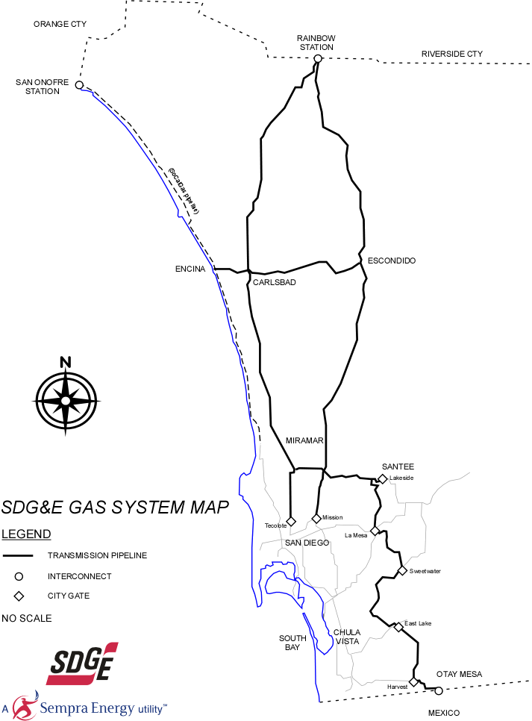

As SDG&E and SoCalGas testified in R.04-01-025, from an integrated system perspective prior to the receipt of supply at Otay Mesa, the SDG&E transmission system serves a local transmission function.
“We are also comfortable with the proposed slack capacity ranges for backbone capacity proposed by the utilities in this proceeding.” D.06-09-039, page 25.
Excludes 45 MMcfd of capacity reserved for an operating margin. SDG&E system capacity is highly dependent upon the location of demand on the SDG&E system and the level of demand upstream of the SDG&E system in Riverside County (SoCalGas’ Rainbow Corridor).
640 MMcfd, SDG&E Gas Capacity Planning and Demand Forecast Semi-Annual Report, May 4, 2007.
SoCalGas and SDG&E note that the forecasted level of demand for the 1-in-10 year cold day condition is a total demand forecast, and have made no assumption regarding the level of firm or interruptible noncore service. During the most recent capacity open season in the Rainbow Corridor and San Diego, the requests for firm service by noncore customers in these areas were significantly less than these forecast values.

