Steam Traps

Review and Acceptance

Information Submitted: |  |  | - Steam Traps Workpaper, EEA Report No. B-REP-05-599-21E, December 2006  - Attachment #1 – Enbridge Steam Trap Survey  - Attachment #2 – kW Engineering Steam Trap Survey  - Attachment #3 – Enbridge Steam Saver Program 2005  - Attachment #4 – Key Parameters for Steam Traps  - Attachment #5 – Armstrong Steam Trap Survey  - Attachment #6 – Enbridge Industrial Steam Saver Program  - Attachment #7 – Steam Boiler Efficiency  - Attachment #8 – CPUC Energy Efficiency Policy Manual
Submitted by: |  |  | Energy and Environmental Analysis, Inc.
Date: |  |  | December 12, 2006
Program Affected:
 | X | Express Efficiency |  |  |  | Energy Efficiency Grant Program (EEGP)
 |  | Process Equipment Replacement (PER) |  |  |  | Custom Process Improvement (CPI)
 |  | Efficient Equipment Replacement (EER) |  |  |  | Recognition Program
 |  | Business Energy Efficiency Program (BEEP)
 |  | Other (please describe)
The following individuals have reviewed the information cited above, and accept this information for determining energy consumption and/or energy savings related to energy efficiency measures.
Tom DeCarlo, PE
Commercial & Industrial Program Manager |  | Approval Date
Southern California Gas Company
Eric Kirchhoff, PE
Energy Efficiency Engineering Supervisor |  | Approval Date
Southern California Gas Company

Revision History
Revision No. | Date | Description | Author
--- | Dec. 26, 2005 | Original release | EEA (S. Knoke)
A | Jan. 20, 2006 | - Minor changes | EEA (S. Knoke)
B | Jul. 6, 2006 | - Added Review and Acceptance page  - Added Revision History page  - Added Disclaimer page  - Added discussion addressing reluctance to adopt technology in Executive Summary  - Added discussion addressing reluctance to adopt technology in Incentive and Payback chapter | EEA (S. Knoke)
C | Nov. 22, 2006 | - Added dry cleaners as a new category  - Measure life reduced to 6 years  - Added steam loop drawing for dry cleaners  - Added a discussion of how steam traps work  - Added a discussion of steam trap failure modes | EEA (S. Knoke)
D | Nov. 28, 2006 | - Implemented reviewer comments  - Added more commercial cost data  - Broadened dry cleaner category to include small commercial | EEA (S. Knoke)
E | Dec. 12, 2006 | - Implemented review comments  - Added attachment on steam tips  - Made steam flow equations consistent  - Added kW Engineering survey as attachment | EEA (S. Knoke)

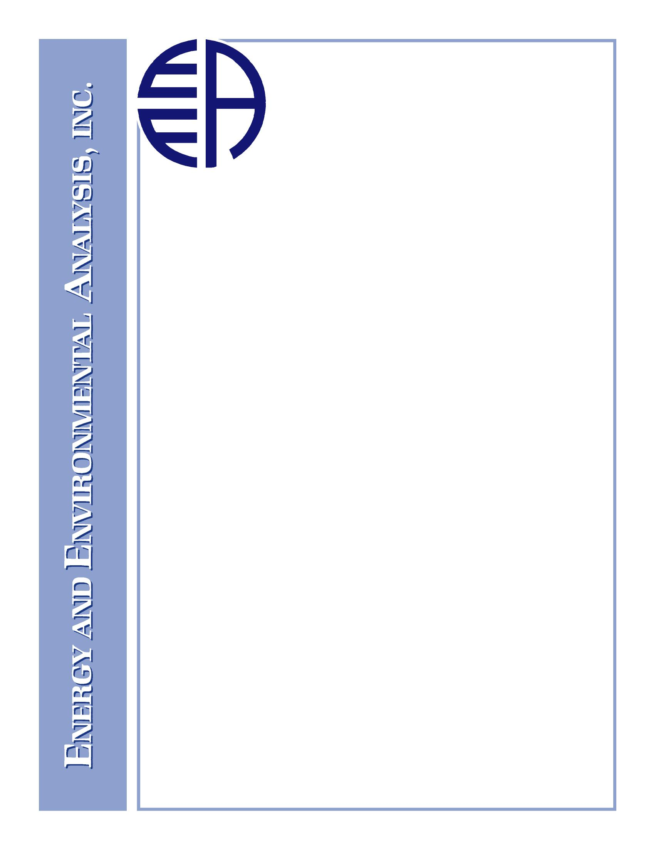
B-REP-05-599-21E
Revision E

Steam Traps
Workpaper for PY2006-2008

December 2006

Prepared for:

Prepared by:

Energy and Environmental Analysis, Inc.

www.eea-inc.com
Headquarters | West Coast Office
1655 N. Fort Myer Drive, Suite 600 | 12011 NE First Street, Suite 210
Arlington, Virginia 22209 | Bellevue, Washington 98005
Tel: (703) 528-1900 | Tel: (425) 688-0141
Fax: (703) 528-5106 | Fax: (425) 688-0180

Disclaimer
The Gas Company has made reasonable efforts to ensure all information is correct. However, neither The Gas Company's publication nor verbal representations thereof constitutes any statement, recommendation, endorsement, approval or guaranty (either express or implied) of any product or service. Moreover, The Gas Company shall not be responsible for errors or omissions in this publication, for claims or damages relating to the use thereof, even if it has been advised of the possibility of such damages.

Executive Summary
H6 (Application Code B)
Equipment Measure(s): Steam traps
Measure Description
Steam systems distribute heat from boilers to satisfy space heating, process, and commercial end use requirements. Steam distribution systems contain steam traps, which are automatic valves that remove condensate, air, and other non-condensable gases, while preventing or minimizing steam loss. Steam traps that fail may allow excess steam to escape, thus increasing the amount of steam that must be generated to meet end use requirements.
All traps are susceptible to wear and dirt contamination and require periodic inspection and maintenance to insure correct operation. Faulty steam traps (blocked, leaking, or blow-through) can be diagnosed with ultrasonic, temperature, or conductivity monitoring techniques (see Appendix A for a description of these failure modes.)
Regular steam trap maintenance and faulty steam trap replacement are steps that minimize steam production. This measure provides an incentive for replacement of faulty steam traps. There are four major types of steam traps: 1) thermostatic (including float and thermostatic), 2) mechanical, 3) thermodynamic, and 4) fixed orifice. This measure applies to all types of steam traps. Float and thermostatic traps are the most common commercial type of trap sold, while mechanical (inverted bucket) are common at dry cleaning establishments.
Market Applicability
Although the payback is short, experience shows that many customers are not replacing faulty steam traps, perhaps due to a general lack of awareness of the potential energy savings. The incentives described in this measure are expected to stimulate adoption primarily due to increased awareness, although the incentives also reduce economic barriers.
This measure is applicable for gas customers that operate process, commercial, and space heating boilers. In these applications, steam traps typically operate between a few psig up to 150 psig (rarely over 250 psig).
Terms and Conditions
Steam traps designed for any pipe sizes are eligible for this program. New construction is not eligible. The customer may be required to provide the location of the new steam trap in the steam loop, make and model number, a specification sheet, steam operating pressure, and receipts showing the cost and purchase date.

Cost Effectiveness Modeling Measure Data
Measure data for cost effectiveness were developed for three steam trap categories: industrial (low and medium pressure) and commercial (based on dry cleaners). Dry cleaner establishments were chosen to represent commercial applications because of the high volume of rebate activity. Unitized cost effectiveness determinants are summarized below.
Parameters | Industrial |  | Commercial
Parameters | Low Pressure (≤15 psig) | Medium Pressure (>15 psig) | ---
Average inlet pressure (psig) | 11 | 86 | 83
Average leak rate (lb/hr per trap rebated) | 6.9 | 27.2 | 5.1
Annual energy savings (therms/yr per trap rebated) | 638 | 2,342 | 139
Incentive amount per trap rebated | $100 | $100 | $100
Measure lifetime (years) | 6 | 6 | 6
Net-to-gross ratio | 0.80 or 0.96 | 0.80 or 0.96 | 0.80 or 0.96
MDSS Measure Code | --- | --- | ---
Application Code | --- | --- | ---
TABLE OF CONTENTS
Page
Executive Summary ii
1. Overview 1
2. Inlet Pressure 3
2.1 Industrial 3
2.2 Commercial 3
3. Operating Hours 4
3.1 Industrial 4
3.2 Commercial 5
4. Leak Rate 5
4.1 Industrial 5
4.2 Commercial 6
5. Boiler Efficiency 7
6. Measure Cost 8
6.1 Industrial 8
6.2 Commercial 9
7. Energy Savings 10
8. Incentive and Payback 12
9. Other 14
9.1 Measure Lifetime 14
9.2 Net to Gross Ratio 14
9.3 Qualifying Efficiency (or Leak Rate) 14
List of Attachments 15
Appendix A. Technology Description 16
A.1 Introduction 16
A.2 Simple Steam Loop 17
A.3 Mechanical Steam Traps 18
A.4 Thermostatic Traps 19
A.5 Thermodynamic Traps 20
A.6 Fixed Orifice Steam Traps 21

LIST OF TABLES
Page
Table 1. Key Parameters 2
Table 2. Average Inlet Pressure Calculation 4
Table 3. Maximum Theoretical Steam Loss per Leaking and Blow-through Trap 6
Table 4. Steam Trap Costs Provided by Vendors 9
Table 5. Estimated Steam Trap Costs for Two Categories (≤ 15 psig and > 15 psig) 9
Table 6. 1/2 inch-Pipe-Size, 125-psig Inverted Bucket Steam Trap Costs Provided by Vendors 10
Table 7. Annual Gas Savings 11
Table 8. Annual Cost Savings 12

LIST OF FIGURES
Page
Figure 1. CEC Efficiency Data (Steam Boilers ≤ 2 MMBtuh) 7
Figure 2. CEC Efficiency Data (Steam Boilers 2-10 MMBtuh) 8
Figure 3. Comparison of Measure Cost and Rebate 13
Figure 4. Payback – With and Without Rebate 13
Figure 5. Simple Steam Loop Diagram 17
Figure 6. Inverted Bucket Trap 18
Figure 7. Armstrong 890 Inverted Bucket Trap 19
Figure 8. Bellows Thermostatic Trap 19
Figure 9. Float and Thermostatic Trap 20
Figure 10. Thermodynamic Disc Steam Trap 21

1. Overview
A summary of key parameters for steam traps is shown in Table 1. A brief overview of these parameters is as follows:
- Average Inlet Pressure – The average inlet pressures for the low-pressure (≤ 15 psig) and medium-pressure (> 15 psig) commercial categories were calculated using an Enbridge survey of steam traps. The two average pressures are 10.9 psig (low-pressure category) and 85.9 psig (medium-pressure category). The average steam trap inlet pressures at dry cleaner establishments is the average boiler operating pressure from a survey performed in Southern California (82.8 psig) by kW Engineering.
- Annual Operating Hours – For industrial customers, an annual operating time of 7,752 hours was used for steam traps based on the assumption that the steam traps will operate under pressure on a continuous basis, except for six weeks per year for plant maintenance and other system shutdowns. For commercial applications (based on dry cleaners), the average annual operating time is less: 2,425 hours (roughly 8 hours per day, 6 days per week, except holidays).
- Average Leak Rate – The average leak rates for the two commercial categories were calculated from Enbridge steam trap surveys. The average leak rate for dry cleaners was calculated from the kW Engineering study of dry cleaners.
- Boiler Efficiency – A boiler efficiency of 80% was used for computing the cost of steam generation.
- Measure Cost – Measure costs were determined based on telephone conversations with steam trap vendors. The costs were weighted based on a steam trap population profile obtained from an Enbridge survey. Steam traps used at dry cleaner establishments are inexpensive inverted-bucket traps.
- Annual Energy Savings – The annual energy savings attributed to the replacement of leaking and blow-through traps was calculated based on the leak rate, operating time, and steam boiler efficiency. The annual energy savings attributed to the wholesale replacement of steam traps at dry cleaners was calculated based on the leak rate, operating time, steam boiler efficiency, and the average percentage of leaking and blow-through traps.
- Incentive/Payback – An incentive of $100/unit has been used in the past to promote the purchase of steam traps. A nominal value of $100 per trap has been used to calculated the paybacks shown in Table 1. However, this nominal incentive level will likely be divided into three separate incentive levels to match each of the three categories of steam traps described in this workpaper. For reference, Table 1 shows payback values for the steam traps with and without the incentive. All estimated payback times are less than 4 months.
Additional comments and calculations follow, and are grouped in the following sections:
- Inlet Pressure
- Operating Hours
- Leak Rate
- Boiler Efficiency
- Measure Cost
- Energy Savings
- Incentive/Payback
- Other
- Measure Lifetime
- Net-to-Gross
- Qualifying Efficiency (or leak rate)
Table 1. Key Parameters
Parameters | Industrial |  | Commercial
Parameters | Low Pressure  (≤15 psig) | Medium Pressure (>15 psig) | ---
Average steam trap inlet pressure (psig) | 10.9 | 85.9 | 82.8
Average heat of evaporation of steam produced (Btu/lb) | 951 | 888 | 890
Average installed boiler efficiency | 80% | 80% | 80%
Boiler energy required to replace lost steam (Btu/lb) | 1,189 | 1,110 | 1,113
Annual operating hours | 7,752 | 7,752 | 2,425
Annual Energy Cost Savings
Average percentage of leaking & blow-thru steam traps | 16% | 16% | 27%
Average leak rate (lb/hr per trap rebated) | 6.9 | 27.2 | 5.1
Annual gas savings (therms/year per trap rebated) | 638 | 2,342 | 139
Annual cost savings ($/year per trap rebated) | $606 | $2,224 | $132
Measure Cost (MC)
Average steam trap cost ($/trap) | $180 | $223 | $77
Incentive
Incentive amount per unit ($/trap) | $100 | $100 | $100
Customer Payback (years)
(yrs, without rebate) | 0.30 | 0.10 | 0.58
(yrs, with rebate) | 0.13 | 0.06 | 0.00
Cost to SCG
Measure Lifetime (years) | 6 | 6 | 6
Net-to-Gross Ratio | 0.96 | 0.96 | 0.96
Cost of NG Savings to SCG (¢/therm) | 2.6 | 0.7 | 12.0

2. Inlet Pressure

2.1 Industrial
The average steam trap inlet pressure was calculated using an Enbridge survey of steam traps. For this workpaper, the Enbridge data was divided into two pressure groups: ≤ 15 psig and > 15 psig. As shown in Table 2, the average pressure for the two groups was calculated by weighting each pressure by the number of leaking traps. For each pressure category, the weighted average is the sum of the average pressure in the range times the number of traps in the range, divided by the sum of the number of traps in the range. The resulting values for the low-and medium-pressure categories are 10.9 and 85.9 psig, respectively.

2.2 Commercial
The average steam trap inlet pressures at dry cleaner establishments is the average boiler operating pressure from a survey performed in Southern California by kW Engineering. The pressures ranged from 74 to 100 psig, with an average of 82.8 psig.

Table 2. Average Inlet Pressure Calculation
Pressure range (psig) | Number of Steam Traps | Average Pressure in Range (psig) | (Average pressure) X (Number in Range) | Average Pressure in Category (psig)
Industrial Low Pressure (≤ 5 psig)
<5 | 234 | 2.5 | 585 | 10.9
5 | 0 | 5 | 0 | 10.9
6 to 9 | 24 | 7.5 | 180 | 10.9
10 | 515 | 10 | 5150 | 10.9
11 to 14 | 249 | 12.5 | 3112.5 | 10.9
15 | 517 | 15 | 7755 | 10.9
Industrial Medium Pressure (> 15 psig)
16 to 19 | 37 | 17.5 | 647.5 | 85.9
20 | 28 | 20 | 560 | 85.9
25 | 33 | 25 | 825 | 85.9
30 | 73 | 30 | 2190 | 85.9
40 | 61 | 40 | 2440 | 85.9
50 | 26 | 50 | 1300 | 85.9
60 | 60 | 60 | 3600 | 85.9
61 to 99 | 175 | 80 | 14000 | 85.9
100 | 45 | 100 | 4500 | 85.9
101 to 124 | 117 | 112.5 | 13162.5 | 85.9
125 | 14 | 125 | 1750 | 85.9
150 | 54 | 150 | 8100 | 85.9
200 | 2 | 200 | 400 | 85.9
250+ | 26 | 425 | 11050 | 85.9
Commercial (based on Dry Cleaners)
74 | 20 | 74 | 1480 | 82.8
80 | 30 | 80 | 2400 | 82.8
100 | 15 | 100 | 1500 | 82.8

3. Operating Hours

3.1 Industrial
Actual operating hours of a steam system vary depending on end-use applications, boiler size, and seasonal variations. Not every steam trap in a system operates for the same number of hours in a year, but most plants keep the main high-pressure system operating to supply minor loads. Therefore, the annual operating hours of the steam traps in a steam system will far exceed the annual equivalent full load hours of the boilers in the same system.
Based on many years of studying steam traps in Enbridge service territory, the average hours of operation of a typical steam trap is estimated to be 7,500 to 8,000 hours per year. Process facilities with nominally 24/7 operations actually operate at most 8,424 hours per year, since they typically shut down the steam system for at least two weeks per year for scheduled maintenance and holidays. California oil refineries never shut down, so their steam traps nominally operate 8,760 hours per year. Since they use valves to segment their steam system, each steam trap may spend only a few hours per year depressurized, to allow maintenance work on steam components in close proximity to the trap.
In this workpaper, the basis for annual operating hours is a steam plant that nominally operates 24 hour per day, 7 days per week, but it is depressurized six weeks per year. That is, the part of the steam system in which the steam trap operates is assumed to be depressurized for a total of six weeks per year for scheduled and unscheduled maintenance activities, implying a total of 7,752 hours per year operating under pressure.

3.2 Commercial
Commercial establishments might operate their steam system anywhere from about 2,000 hours per year (8 hours/day, 5 days/week) to about 6,000 hours per year (16 hours/day, 7 days/week). In the kW Engineering study, the steam system operating schedule was obtained for each dry cleaner establishment. They report operating their steam system 7.5 to 9 hours per day, 6 days per week, year-round except holidays. The average annual operating time for dry cleaners studied is 2,425 hours per year.

4. Leak Rate

4.1 Industrial
In steam systems that have not been maintained for 3 to 5 years, between 15% to 30% of the installed steam traps may have failed. More specifically, a large Enbridge study yielded 16.3% of steam traps were leaking or failed open (blow-through), with an additional 7.7% blocked. A recent survey of 2,650 steam traps at a large Southern California oil refinery found 27.7% were “leaking heavily” or blow-through, with an additional 6.3% blocked. See Appendix A for a further discussion of the these terms for faulty steam traps.
The average leak rates for leaking and blow-through steam traps in the two pressure categories are calculated from two Enbridge surveys. Attachment #3 reports the results of six years of steam trap surveys (2000-2005) with 41,124 steam traps tested: 6,719 leaking (plus blow-through) traps resulted in an estimated 707.2 million lb/year of steam lost. Assuming the operating schedule discussed above, 7,752 hours/year, the average steam loss rate per leaking trap is 13.6 lb/hr. In contrast, the “leaking heavily” and blow-through steam traps at California oil refineries (including some large orifice traps at over 250-psig pressure) are reported to lose an average of 200 lb/hr of steam.
The value of 13.6 lb/hr is an average over a wide range of steam trap inlet pressures. To find the average leak rate for low-and medium-pressure traps, Napier’s equation was used:
Flow Rate = (Discharge Coefficient) X (Orifice Area) X (Inlet Pressure + 14.7) / 70 Eqn-1
where the flow rate is measured in lb/s, the discharge coefficient of a sharp-edged orifice is used (0.62), the orifice area in square inches, and the inlet pressure in psig. Assuming that the orifice area is not correlated to inlet pressure, then the flow rate is proportional to the absolute steam pressure at the inlet. With this assumption, the average flow rate through leaking steam traps in each pressure category is calculated from the average steam loss rate for all leaking traps times the average inlet pressure for the steam traps in each pressure category divided by the average inlet pressure for all steam traps. The results are shown in Table 3. Eqn-1 gives the maximum possible theoretical flow rate of steam through the steam trap; however, Enbridge has a included an adjustment factor of 50% to account for the fact that the actual leak rate in most cases is less than the maximum theoretical leak rate. The leak rates shown in Table 3 do not include this adjustment factor, hence the value of 13.6 lb/hr calculated above appears as 27.2 lb/hr in this table. This is done to allow consistent treatment of the energy savings analysis in Section 7 below, that is, consistent between industrial and commercial.
Table 3. Maximum Theoretical Steam Loss per Leaking and Blow-through Trap
Parameters | All Pressures | Low Pressure | Medium Pressure
Parameters | (0-600 psig) | (≤15 psig) | (>15 psig)
Average inlet pressure (psig) | 35.5 | 10.9 | 85.9
Average inlet pressure (psia) | 50.2 | 25.6 | 100.6
Maximum steam loss per leaking&blow-thru trap (lb/hr) | 27.2 | 13.8 | 54.4
From Enbridge Data

4.2 Commercial
The percentage of steam traps that were leaking or failed open (blow-through) is much higher for dry cleaner establishments than for industrial sites. A study by Armstrong International found 27.8% of steam traps at dry cleaning and laundry facilities were leaking or blow-through. In the kW Engineering study of small dry cleaners establishments in Southern California, they found 27.0% were leaking or blow-through, with 15.9% blocked.
The average leak rates for leaking and blow-through steam traps at dry cleaning establishments is based on average boiler operating steam pressure (82.8 psig) collected for the kW Engineering study (see Table 2). Orifice diameters range from 7/64th inch to 3/16th inch at dry cleaners. The most common value of 1/8th inch was used to calculate the maximum leak rate using Eqn-1 above, with the result of 38.1 lb/hr per trap failed open. The adjustment factor developed by Enbridge is not included in this number.

5. Boiler Efficiency
To calculate the cost of steam loss from a leaking trap, it is necessary to have an estimate of the efficiency of the steam generation boiler. To determine representative steam boiler efficiencies, data from the California Energy Commission (CEC) were examined. CEC lists several hundred steam boilers, and these boilers were divided into two groups:
- ≤ 2 MMBtuh (steam only)
- 2-10 MMBtuh (steam only)
The CEC results are plotted in Figure 1 and Figure 2. As shown in both figures, the boiler listings all start at 80%, with a relatively large number of boilers all rated at 80% efficiency. Based on this data, a baseline efficiency value of 80% was used to compute the cost of steam generation.
Figure 1. CEC Efficiency Data (Steam Boilers ≤ 2 MMBtuh)
Figure 2. CEC Efficiency Data (Steam Boilers 2-10 MMBtuh)

6. Measure Cost

6.1 Industrial
A vendor survey was conducted to collect retail cost data for steam traps (these prices do not include installation). Cost data were collected for three of the four main types of traps, including:
- Float & Thermostatic
- Mechanical (inverted bucket)
- Thermodynamic
The results of the vendor survey are shown in Table 4. The prices are grouped by steam trap type and by maximum operating pressure. This workpaper is focused on steam traps with pipe connections up to 2 inches, and representative prices were therefore collected within this size range. Based on discussions with vendors and with Enbridge, about half of all steam traps sold are of the float and thermostatic design, and the remaining half are split between inverted bucket and thermodynamic. For averaging purposes, the cost results are therefore split into two categories: 1) float and thermostatic and 2) other (includes both inverted bucket and thermodynamic). The average price shown at the bottom of Table 4 represents the average price between the two categories.

Table 4. Steam Trap Costs Provided by Vendors
Type of Steam Trap | Pressure (psig)
Type of Steam Trap | 15 | 30 | 75 | 125 | 150 | 180 | 200 | 250
Float & Thermostatic
3/4 inch | $127 | $150 | $203 | $207 | $454 | $454 | $454 | ---
1 1/2 inch | $258 | $314 | $352 | $352 | --- | --- | --- | ---
Average | $192 | $232 | $278 | $279 | $454 | $454 | $454 | ---
Other
Inverted bucket | $82 | $82 | $82 | $82 | $105 | $105 | $105 | $105
1/2 inch thermodynamic | $185 | $185 | $185 | $185 | $185 | $185 | $185 | $185
3/4 inch thermodynamic | $235 | $235 | $235 | $235 | $235 | $235 | $235 | $235
Average | $168 | $168 | $168 | $168 | $175 | $175 | $175 | $175
Average | $180 | $200 | $223 | $223 | $315 | $315 | $315 | $175
An Enbridge survey (see Attachment #1) was used to determine a typical population profile for leaking traps. This population profile is shown in Table 5. The cost data from Table 4, combined with the population profile information in Table 5, was then used to compute a weighted cost for steam traps that operate above and below 15 psig. These average results are shown at the bottom of Table 5. Steam traps at California oil refineries typically cost $188 each. In addition, some facilities are installing a universal connector with each trap ($150) to speed up the replacement process next time.
Table 5. Estimated Steam Trap Costs for Two Categories (≤ 15 psig and > 15 psig)
Parameters | Pressure (psig)
Parameters | 15 | 30 | 75 | 125 | 150 | 180 | 200 |  |  | 250
Number of Leaking Traps | 1,539 | 171 | 235 | 264 | 54 | 0 |  | 2 | 26
Total Replacement Cost | $276,892 | $34,145 | $52,207 | $58,887 | $16,983 | $0 |  | $629 | $4,553
Average Cost per Trap | $180 | $223

6.2 Commercial
The steam traps sold to small commercial operations, such as dry cleaner establishments, are almost all inverted bucket traps rated for 125 psig with ½-inch pipe size. Table 6 lists the prices found for inverted bucket steam traps of the pipe size and pressure rating commonly used in small commercial steam systems, such as dry cleaners: 1/2 inch and 125 psig. The average price is $77, which does not include installation. Where volume discounts are offered, the price for 15 traps is used, since that is a common number of steam traps in dry cleaners steam systems. Less common at 1/2 inch and 125 psig are thermostatic traps (also averaging $77) and the more expensive thermodynamic disc traps (averaging $138).

Table 6. 1/2 inch-Pipe-Size, 125-psig Inverted Bucket Steam Trap Costs Provided by Vendors
Source | Make/Model | Retail Price
From Table 4 above |  | $82
Steam trap installer in LA area | Quoted value for “average retail price of steam traps for dry cleaners” | $99
Cleaner's Supply | Armstrong 880 with strainer | $66
 | Armstrong 890 with no strainer | $41
 | United #850 with strainer | $35
Grainger | Grainger 4NU78 (with strainer) | $114
McMaster-Carr | McMaster-Carr 4897K27 (with strainer) | $100
Average |  | $77

7. Energy Savings
Table 7 shows the gas savings calculation methodology. The average steam trap inlet pressures are taken from Table 2. The heats of vaporization of steam correspond to the average steam trap inlet pressures, with the implicit assumption that the average boiler pressure (where the vaporization occurs) is at essentially that same pressure. The boiler energy to replace the lost steam (Btu of gas/lb of steam) is the heat of vaporization divided by the boiler efficiency of 80%. The annual operating hours are taken from Section 3; and the industry average percentage of leaking & blow-through traps was discussed in Section 4. The lower section of the table considers the average steam loss at maximum flow through the trap, not the average actual steam loss. The average maximum steam loss (lb/hr per trap) is taken from Section 4. The annual average maximum steam loss (lb/yr per trap) is the product of the average maximum steam loss (lb/hr) and the annual plant operating hours. The annual average maximum gas savings (therms/yr per trap) is the product of the boiler energy to replace the lost steam (Btu of gas/lb of steam) and the annual average maximum steam loss (lb/yr per trap).

Table 7. Annual Gas Savings
Parameters | Industrial |  | Commercial
Parameters | Low Pressure (≤15 psig) | Medium Pressure (>15 psig) | ---
Average steam trap inlet pressure (psig) | 10.9 | 85.9 | 82.8
Heat of vaporization (Btu/lb) | 951 | 888 | 890
Average installed boiler efficiency | 80% | 80% | 80%
Boiler energy to replace lost steam (Btu of gas/lb of steam) | 1,189 | 1,110 | 1,113
Annual operating hours | 7,752 | 7,752 | 2,425
Industry average of leaking&blow-thru steam traps | 16% | 16% | 27%
Steam loss at maximum flow
Average steam loss (lb/hr per trap) | 13.8 | 54.4 | 38.1
Average annual steam loss (lb/yr per trap) | 107,364 | 421,906 | 92,476
Annual gas savings (therms/year per trap) | 1,276 | 4,683 | 1,029
The annual cost savings and the paybacks are calculated in Table 8. Also shown are the results of several steam trap surveys discussed in Section 4. On the industrial side, the results of the Enbridge steam trap survey are used; on the commercial side, the results of the kW Engineering steam trap survey of dry cleaners are used. The steam loss from a normal trap should be negligible and, from a blocked trap, zero. The maximum theoretical steam loss through a blow-through trap is taken from Table 7. The Enbridge adjustment factor is used to obtain the average steam loss per leaking and blow-through trap. Enbridge developed an adjustment factor of 50% to account for the fact that the actual leak rate in almost all cases is less than the maximum theoretical leak rate, sometimes a lot less. On the industrial side, standard practice is to test the steam traps at a facility and replace the leaking and blow-through traps. The Gas Company rebates each trap replaced. Hence, the average steam loss per trap rebated is the average steam loss per leaking and blow-through trap (638 and 2,342 therm/yr per trap rebated for low and medium pressure, respectively). On the commercial side, primarily at dry cleaners, it is common practice to avoid the cost of testing the steam traps and simply replace all of the steam traps at the facility. This is a common practice for several reasons. Typically, the cost of testing a steam trap represents a significant portion of the cost of simply replacing a steam trap. Also, due to frequent transfers in ownership, the new owners are less likely to know the maintenance history of the equipment. And due to historically poor steam system maintenance in small commercial establishments, there is a higher likelihood of the need for replacement compared to industrial steam systems. To obtain the average steam loss per trap rebated (139 therms/yr per trap rebated), the average steam loss per leaking and blow-through trap (515 therms/yr per trap) is multiplied by the average percentage of leaking and blow-through traps (27.0% in the survey of dry cleaners).

Table 8. Annual Cost Savings
Parameters | Industrial |  |  |  | Commercial
Parameters | Low Pressure  (≤15 psig) |  | Medium Pressure  (>15 psig) |  | ---
Parameters | (%) | Therms/yr per trap | (%) | Therms/yr per trap | (%) | Therms/yr per trap
Normal traps (%) | 76.0% | 0 | 76.0% | 0 | 57.1% | 0
Blocked traps (%) | 7.7% | 0 | 7.7% | 0 | 15.9% | 0
Leaking&blow-thru traps (%) | 16.3% | --- | 16.3% | --- | 27.0% | ---
Maximum blow-thru | --- | 1,276 | --- | 4,683 | --- | 1,029
Averaging factor | 50% | --- | 50% | --- | 50% | ---
Average steam loss | --- | 638 | --- | 2,342 | --- | 515
All traps (%) | --- | --- | --- | --- | 100.0% | 139
Cost Parameters
Gas rate (¢/therm) |  | 95 |  | 95 |  | 95
Annual cost savings ($/yr per trap rebated) |  | $606 |  | $2,224 |  | $132
Average steam trap cost ($/trap) |  | $180 |  | $223 |  | $77
Incentive amount per unit ($/trap) |  | $100 |  | $100 |  | $100
Payback without rebate (yr) |  | 0.30 |  | 0.10 |  | 0.58
Payback with rebate (yr) |  | 0.13 |  | 0.06 |  | 0.00
The annual cost savings ($/yr per trap rebated) is the product of the average steam loss per trap rebated (therms/yr per trap rebated) and the gas rate (divided by a hundred cents/dollar). The estimated annual cost savings for low-and medium-pressure steam traps are $606 and $2,224 per trap rebated, respectively. Replacement of normal and blocked traps is not included. The estimated annual cost savings for commercial (dry cleaners) steam traps is $132 per trap rebated, when all steam traps at a facility are replaced without testing. The average steam trap cost is taken from Section 6. The payback is the average cost of the replacement traps to the customer (with or without the rebate) divided by the annual cost savings per trap.

8. Incentive and Payback
The incentive level for steam traps in recent years has been $100/unit. Using this incentive level, a comparison of the measure cost (not including installation) and the rebate amount for average size units is shown in Figure 3. A payback illustration, based on a gas cost of 95 ¢/therm, is shown in Figure 4. As indicated, without an incentive, the payback for steam trap replacement is approximately 4 months for low-pressure traps (≤ 15 psig), about 2 months for medium-pressure traps (> 15 psig), and about 10 months for dry cleaner traps. With a $100 per trap incentive, the payback times are approximately cut in half, except for dry cleaners, where the rebate covers the measure cost (not including installation).
Even though the payback without the incentives is short, experience shows that many gas customers are not testing their steam traps and replacing faulty ones. Lack of awareness is believed to be one factor that is limiting more widespread replacement of steam traps, and the incentives described in this workpaper are expected to increase awareness, thereby stimulating the adoption of steam trap test and replacement programs. While the primary benefit of this measure is expected to be increased awareness, this measure will also reduce economic barriers, which can be a major obstacle for customers that are cash constrained.
Figure 3. Comparison of Measure Cost and Rebate

Figure 4. Payback – With and Without Rebate

9. Other

9.1 Measure Lifetime
Steam traps are not specifically identified in the CPUC Energy Efficiency Policy Manual. These devices have been categorized in the past as a “System Controls” measure, which the CPUC identifies as having a 15 year life.
During the course of conversations with vendors to collect cost data for this workpaper, steam trap life was also discussed. Vendors and manufacturers did not provide references for rigorous studies, but suggested that inverted bucket steam traps have a typical life in the range of 5-7 years, float and thermostatic of 4-6 years, and thermodynamic disc of 1-3 years. Thermodynamic steam traps at refineries have a life of only 2-3 years. However, three years at a refinery is over 25,000 hours, while 6 years at a commercial dry cleaners is less than 15,000 hours of operation.
A value of 6 years is used in this workpaper as the recommended steam trap life.

9.2 Net to Gross Ratio
The net to gross ratio is an estimate of free ridership occurring in energy efficiency programs. Free riders are program participants who would have replaced faulty steam traps even if a rebate were not offered. The CPUC Energy Efficiency Policy Manual recommends a value of 0.96 for all equipment covered under the Express Efficiency Program and 0.80 for equipment in the Business Energy Efficiency Program (BEEP). Both values are shown in Table 1.

9.3 Qualifying Efficiency (or Leak Rate)
No minimum leak rate is required. This measure is currently written such that any steam trap with pipe connections up to 2 inches qualifies. On the industrial side, standard practice is to test the steam traps at a facility and replace the leaking and blow-through traps first, and replace blocked steam trap if time allows. On the commercial side, especially at dry cleaners, the practice is to avoid the cost of testing the steam traps and simply replace all of the steam traps at the facility. The Gas Company rebates each trap replaced.

List of Attachments
The following attachments support this workpaper (supplied as separate electronic files):
- Attachment #1 – Enbridge Steam Trap Survey
- Attachment #2 – kW Engineering Steam Trap Survey
- Attachment #3 – Enbridge Steam Saver Program 2005
- Attachment #4 – Key Parameters for Steam Traps
- Attachment #5 – Armstrong Steam Trap Survey
- Attachment #6 – Enbridge Industrial SteamSaver Program
- Attachment #7 – Steam Boiler Efficiency
- Attachment #8 – CPUC Energy Efficiency Policy Manual

Appendix A. Technology Description

A.1 Introduction
Steam traps are automatic valves used in every steam system to remove condensate, air, and other non-condensable gases while preventing or minimizing the passing of steam. If condensate is allowed to collect, it reduces the flow capacity of steam lines and the thermal capacity of heat transfer equipment. In addition, excess condensate can lead to “water hammers,” with potentially destructive and dangerous results. Air that remains after system startup reduces steam pressure and temperature and may also reduce the thermal capacity of heat transfer equipment. Non-condensable gases, such as oxygen and carbon dioxide, cause corrosion. Finally, steam that passes through the trap provides no heating service. This effectively reduces the heating capacity of the steam system or increases the amount of steam that must be generated to meet the heating demand.
The temperature of the liquid condensate discharged from steam traps is determined by the pressure in the condensate collection vessel and return piping. Many condensate return systems operate at atmospheric pressure; hence the temperature of the condensate is about 212 °F immediately after being discharged from the steam trap. This high-temperature distilled water contains a significant amount of heat and should be returned to the boiler. For example, the gas energy savings from returning 1,000 lb/hr of condensate at 200 °F to an 80% efficient boiler, rather than using makeup water at 50 °F is 187.5 MBtuh.
Steam traps have three failure modes: blocked, leaking, and blow-through. A blocked steam trap does not allow steam or condensate to pass through it. Steam traps are blocked by solid matter (e.g., rust chips); strainers are often installed on the upstream side of the trap to reduce the chance of blockage, but even they can be blocked under severe conditions. Depending upon the type of steam trap, a normal steam trap passes no steam or a negligible flow of steam. A leaking steam trap passes an above-normal flow of steam, perhaps due to valve inside the steam trap getting stuck in a partially open position. The steam flow through a leaking steam trap can range from a negligible flow to the maximum possible flow. A steam trap in the blow-through condition has failed open; the steam flow is the maximum possible through the steam trap. Enbridge concluded from their studies of steam traps that the average steam flow through leaking and blow-through steam traps is about 50% of the maximum possible flow.
In general, there are four types of steam traps:
- Mechanical (includes inverted bucket, the least expensive)
- Thermostatic (includes float & thermostatic, the most common)
- Thermodynamic (includes disc)
- Fixed orifice
The range of pipe connection size varies by type of steam trap:
- Mechanical (inverted bucket) steam traps ranged from ½-inch to 2.5-inch
- Thermostatic are ¼-inch to 1-inch
- Float and thermostatic (F&T) steam traps range in pipe size from ¼-inch to 3-inch
- Thermodynamic and disc range from 3/8-inch to 1-inch
- Fixed orifice range from ½-inch to 2-inch

A.2 Simple Steam Loop
Steam traps are an integral part of all steam loops. Figure 5 shows a simple steam loop with two steam traps. The recirculation pump in the lower left corners establishes the steam pressure, which in turn sets the boiling point of the condensate. Condensate is primarily water, but with additives to extend the life of the components of the steam loop. Boiler blowdown of a small portion of the steam flow is also used to extend the life of the components. The boiler unit is on the left: a good boiler will include an economizer to preheat the liquid condensate, the boiler to make steam, a superheater to increase the steam temperature above the boiling point, and perhaps a combustion air preheater. The superheated steam passes through the main steam line, an insulated pipe, on its way to the thermal load. The steam trap before the thermal load pulls off whatever has condensed in the main steam line along the way, which is especially useful during start-up or shut-down. Most of the steam is condensed in the thermal load, and the steam trap downstream of the thermal load keeps the remaining steam out of the condensate return line. The condensate return line is hot, and should be insulated as well. The condensate is collected in a tank, with vapor (air plus steam) over liquid condensate. Make-up water is added to this tank to replace steam and condensate lost to blowdown, the process, or leaks. The recirculation pump draws off the bottom of the condensate tank. If the condensate tank is at atmospheric pressure, a larger pump (larger head and larger power) is required than if the tank is pressurized to near the boiler pressure.
Figure 5. Simple Steam Loop Diagram

A.3 Mechanical Steam Traps
Mechanical steam traps are mostly inverted bucket steam traps. In inverted bucket traps, steam is contained within an inverted bucket floating in condensate (see Figure 6). A common steam trap at small commercial facilities, such as dry cleaners, is the Armstrong 890 steam trap (see Figure 7). As the level of condensate rises, it is discharged. Inverted bucket traps require water within the bucket, called the prime, to operate. This trap is most appropriate for steady steam loads. Condensate is discharged intermittently by inverted bucket steam traps.
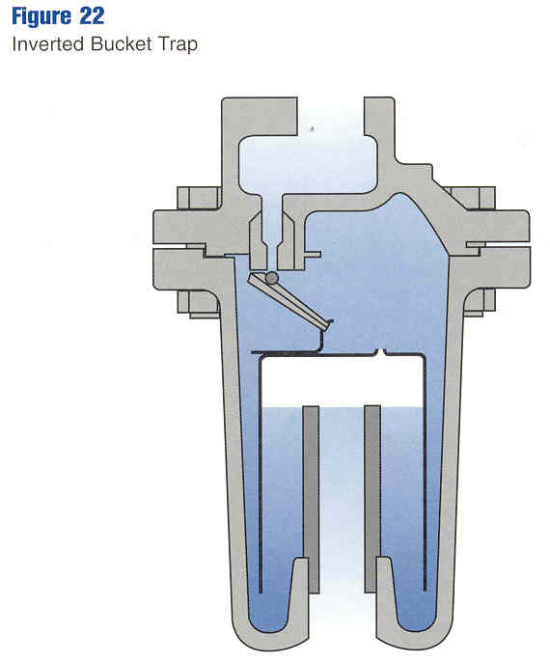
Source: “Design of Fluid Systems”, Spirax Sarco, 2000
Figure 6. Inverted Bucket Trap
The operation of a mechanical steam trap is driven by the difference in density between condensate and steam. The denser condensate rests on the bottom of any vessel containing the two fluids. As additional condensate is generated, its level in the vessel will rise. This action is transmitted to a valve via either a “free float” or a float with connecting levers in a mechanical steam trap. In the inverted bucket steam trap, steam entering the submerged bucket causes it to rise upward and seal the valve against the valve seat. As the steam condenses inside the bucket or if condensate is predominately entering the bucket, the weight of the bucket will cause it to sink and pull the valve away from the valve seat. Any air or other non-condensable gases entering the bucket will cause it to float and the valve to close. Thus, the top of the bucket has a small hole to allow non-condensable gases to escape. The hole must be relatively small to avoid excessive steam loss. The average useful life of inverted bucket steam traps is 5-7 years. When the inverted bucket traps has a stainless steel bucket, the trap life can be extended by replacing the valve mechanism and seat every 3 to 5 years.
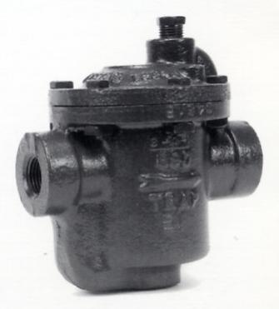
Source: Armstrong International
Figure 7. Armstrong 890 Inverted Bucket Trap

A.4 Thermostatic Traps
Thermostatic steam traps include bimetallic metal, liquid-filled bellows, thermostatic, and “float and thermostatic” (F&T). The operation of a thermostatic steam trap is driven by the difference in temperature between steam and sub-cooled condensate. Valve actuation is achieved via expansion and contraction of a bimetallic element or a liquid-filled bellows. Figure 8 shows a bellows thermostatic trap. As condensate cools, the volume of an enclosed bellows decreases and the discharge valve opens. Thermostatic traps always cause some condensate to remain in the system. Condensate is discharged continuously. Thermostatic traps close when exposes to hot steam. An increase in upstream pressure tends to close the valve and vice versa. While higher temperatures still work to close the valve, the relationship between temperature and bellows expansion can be made to vary significantly by changing the fluid inside the bellows. Using water within the bellows results in nearly identical expansion as steam temperature and pressure increase, because pressure inside and outside the bellows is nearly balanced.
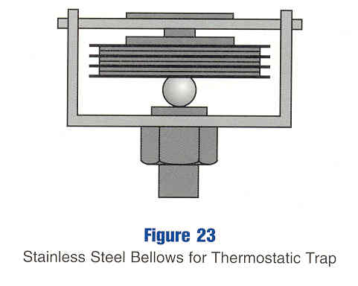
Source: “Design of Fluid Systems”, Spirax Sarco, 2000.
Figure 8. Bellows Thermostatic Trap
A bimetallic thermostatic trap also closes when exposure to steam expands the bimetallic element. Upstream pressure works to open the valve in a bimetallic trap, while expansion of the bimetallic element works in the opposite direction. Changes in the downstream pressure will affect the temperature at which the valve opens or closes. In addition, the nonlinear relationship between steam pressure and temperature requires careful design of the bimetallic element for proper response at different operating pressures.
In contrast to the inverted bucket trap, both types of thermostatic traps allow rapid purging of air at startup. The inverted bucket trap relies on fluid density differences to actuate its valve. Therefore, it cannot distinguish between air and steam and must purge air (and some steam) through a small hole. A thermostatic trap, on the other hand, relies on temperature differences to actuate its valve. Until warmed by steam, its valve will remain wide open, allowing the air to easily leave. After the trap warms up, its valve will close, and no continuous loss of steam through a purge hole occurs.
Recognition of this deficiency (continuously purging air and some steam) with inverted bucket traps or other simple mechanical traps led to the development of float and thermostatic traps (Figure 9). In F&T traps, condensate is discharged when the rising level of condensate lifts a float attached to a level. A thermostatically operated vent discharges air from the top of the trap. The condensate release valve is driven by the level of condensate inside the trap, while the air release valve is driven by the temperature of the trap. Float and thermostatic traps have good air removal characteristics. However, the internal valves and seats must be matched to the steam pressure or the trap can fail in the closed position. The average useful life of F&T steam traps is 4-6 years.
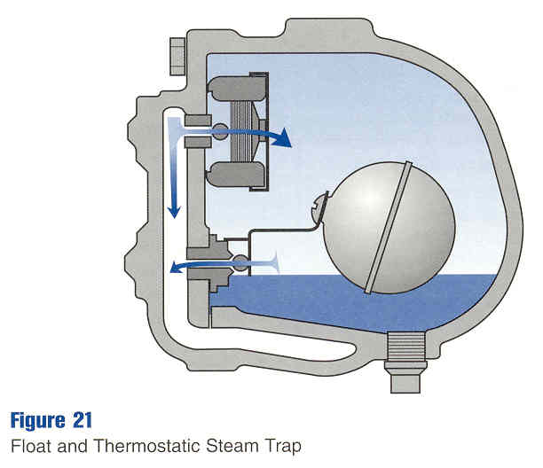
Source: “Design of Fluid Systems”, Spirax Sarco, 2000.
Figure 9. Float and Thermostatic Trap

A.5 Thermodynamic Traps
Thermodynamic trap valves are driven by differences in the pressure applied by steam and condensate, with the presence of steam or condensate within the trap being affected by the design of the trap and its impact on local flow velocity and pressure. Thermodynamic traps include three types: disc, piston, and lever. Disc, piston, and lever designs are three types of thermodynamic traps with similar operating principles; a disc trap is shown in Figure 10. Thermodynamic disc traps have a disc situated on a central orifice. When subcooled condensate enters the trap, the increase in pressure lifts the disc off its valve seat and allows the condensate to flow into the chamber and out of the trap. The narrow inlet port results in a localized increase in velocity and decrease in pressure as the condensate flows through the trap. As the condensate entering the trap increases in temperature, it will eventually flash to steam because of the localized pressure drop in the port. This increases the velocity and decreases the pressure even further, causing the disc to snap closed against the seating surface. The moderate pressure of the flash steam on top of the disc acts on the entire disc surface, creating a greater force than the higher pressure steam and condensate at the inlet, which acts on a much smaller portion of the opposite side of the disc. Eventually, the disc chamber will cool, the flash steam will condense, and inlet condensate will again have adequate pressure to lift the disc and repeat the cycle. Condensate is therefore discharged intermittently. The average useful life of thermodynamic disc steam traps is 1-3 years.
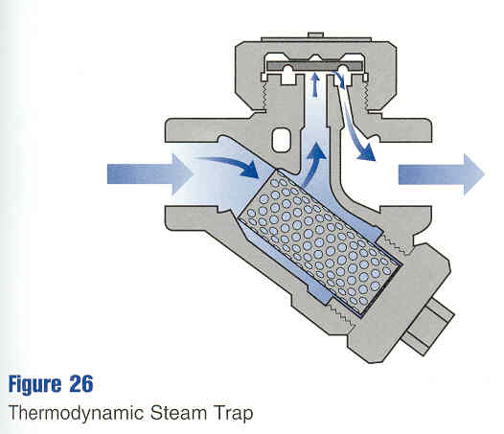
Source: “Design of Fluid Systems”, Spirax Sarco, 2000.
Figure 10. Thermodynamic Disc Steam Trap

A.6 Fixed Orifice Steam Traps
Fixed orifice steam traps contain a set orifice in the trap body and continually discharge condensate. As the rate of condensation decreases, the condensate temperature will increase, causing a throttling in the orifice and reducing capacity due to steam flashing on the downstream side. An increased load will decrease flashing and the orifice capacity will become greater.
Orifice steam traps function best in situations with relatively constant steam loads. In situations where steam loads vary, the orifice trap will allow steam to escape or condensate to back up into the system. Varying loads, such as those found in most steam heating systems, are usually not good candidates for orifice steam traps.

These preliminary incentive amounts are subject to change and are used only for calculation purposes.
NTG is 0.96 for Express Efficiency Program and 0.80 for Business Energy Efficiency Program (BEEP).
See Appendix A for a description of steam traps.
See Attachment #1
See Attachment #2
See Attachment #1 and Attachment #3
Detailed calculations shown in Attachment #4.
Based on data obtained for dry cleaners.
Gas rate of 95 ¢/therm used for payback calculations.
See Attachment #1.
See tab named “Dry Cleaners Data” in Attachment #4
Private conversation with large oil refinery in Southern California, Nov. 21, 2006.
Energy Tips – Steam, Steam Tip Sheet #1, DOE/G0-102006-2248, U.S. Department of Energy, January 2006.
See Attachment #1 and Attachment #3.
Some leaking traps have the trap orifice partially blocked. In a leaking trap experiencing blow-through, the trap orifice is completely open, allowing the maximum leak rate.
Private conversation with large oil refinery in Southern California, Nov. 21, 2006.
See Attachment #6
See Attachment #3
See Attachment #5
CEC efficiency data included in Attachment #7, and also available online at http://www.energy.ca.gov/appliances/appliance/excel_based_files/boilers/.
Vendors surveyed did not provide pricing for orifice type traps.
Private conversation with Enbridge, December 2005.
Private conversation with large oil refinery in Southern California, Nov. 21, 2006.
See Attachment #3.
See the Dry Cleaners Data tab in Attachment #4.
See Attachment #6
See Attachment #8.
Gary Ford, Armstrong International, Nov. 8, 2006.
Private conversation with large oil refinery in Southern California, Nov. 21, 2006.
Adapted from “Process Heating: Steam Traps,” by the University of Dayton Industrial Assessment Center.
187,500 Btu/hr = 1,000 lb/hr X 1 Btu/lb-F X (200 F – 50 F) / 80%
Gary Ford, Armstrong International, Nov. 8, 2006
Gary Ford, Armstrong International, Nov. 8, 2006
Gary Ford, Armstrong International, Nov. 8, 2006

