ORA DATA REQUEST

A.15-04-012: San Diego Gas & Electric Company (SDG&E)

SDG&E TY2016 General Rate Case Phase 2 Amended Application

Date: 7/31/2026

To: Parina P. Parikh  Regulatory Case Manager  Thomas R. Brill  Counsel for SDG&E | Phone:  Email: PParikh@SempraUtilities.com  Phone: (858) 654-1601  Email: TBrill@semprautilities.com

From: Lee-Whei Tan  Project Coordinator  Aaron Lu  Project Coordinator  Benjamin Gutierrez  Originator  Greg Heiden  Attorney for ORA | Phone: (415) 703-2901  Email: lee-whei.tan@cpuc.ca.gov  Phone: (415) 703-2409  Email: aaron.lu@cpuc.ca.gov  Phone: (415)703-2874  E-mail: bg3@cpuc.ca.gov  Phone: (415) 355-5539  Email: gregory.heiden@cpuc.ca.gov

Re: Data Request No. ORA-A.15-04-012 Amended-SDGE-006

Responses Due: 1/29/2016
Instructions

You are instructed to answer the following Data Requests in the above-captioned proceeding, with written, verified responses per Public Utilities Code §§ 309.5 and 314, and Rules 1.1 and 10.1 of the California Public Utilities Commission’s Rules of Practice and Procedure. Restate the text of each request prior to providing the response. For any questions, email the ORA contact(s) above with a copy to the ORA attorney.
Each Data Request is continuing in nature. Provide your response as it becomes available, but no later than the due date noted above. If you are unable to provide a response by this date, notify ORA as soon as possible, with a written explanation as to why the response date cannot be met and a best estimate of when the information can be provided. If you acquire additional information after providing an answer to any request, you must supplement your response following the receipt of such additional information.
Identify the person providing the answer to each data request and his/her contact information. Responses should be provided both in the original electronic format, if available, and in hard copy. (If available in Word format, send the Word document and do not send the information as a PDF file.) All electronic documents submitted in response to this data request should be in readable, downloadable, printable, and searchable formats, unless use of such formats is infeasible. Each page should be numbered. If any of your answers refer to or reflect calculations, provide a copy of the supporting electronic files that were used to derive such calculations, such as Excel-compatible spreadsheets or computer programs, with data and formulas intact and functioning. Documents produced in response to the data requests should be Bates-numbered, and indexed if voluminous. Responses to data requests that refer to or incorporate documents should identify the particular documents referenced by Bates-numbers or Bates-range.
If a request, definition, or an instruction, is unclear, notify ORA as soon as possible. In any event, answer the request to the fullest extent possible, specifying the reason for your inability to answer the remaining portion of the Data Request.

Data Requests

Marginal Commodity Costs:

- Re: Chapter 7 MGCC workpaper:
SDG&E’s next planned capacity additions during the period of the GRC Phase 2 (2016-2018) are in the form of advanced CTs–Pio Pico uses 3 LMS100’s and is expected to come online in 2018 and the Carlsbad Energy Center uses 5 LMS 100’s and is expected to come online in 2018.
Please explain why SDG&E chose a conventional CT rather than an Advanced CT plant using GE LMS100 turbines as the basis for the MGCC calculation.

- In the Chapter 7 CTC Allocation workpaper, there are factors that adjust each class’ proportion of top 100 LOLE hourly loads to 2016:
 | Res | Sm Comm | M/L C&I | Ag | Lighting | Total
Factor | 1.04 | 1.03 | 0.99 | 1.09 | 0.82 | 1.01

Please provide the detail for the derivation of these factors and provide supporting documents and sources of data.

- SDG&E’s response to Data Request 3 (concerning the CTC Allocation workpaper) does not seem to show a shift to later hours among the observed Top 100 LOLE Hours for 2009-2013 (see the distribution below, which shows LOLE hours shifting from 2pm-6pm to a wider spread- both earlier and later in the day, for 2013). How does SDG&E reconcile the contradiction between the observed widening of loss of load hours to earlier and later in the day (in 2013) and its proposal to shift TOU peak periods to later in the day?

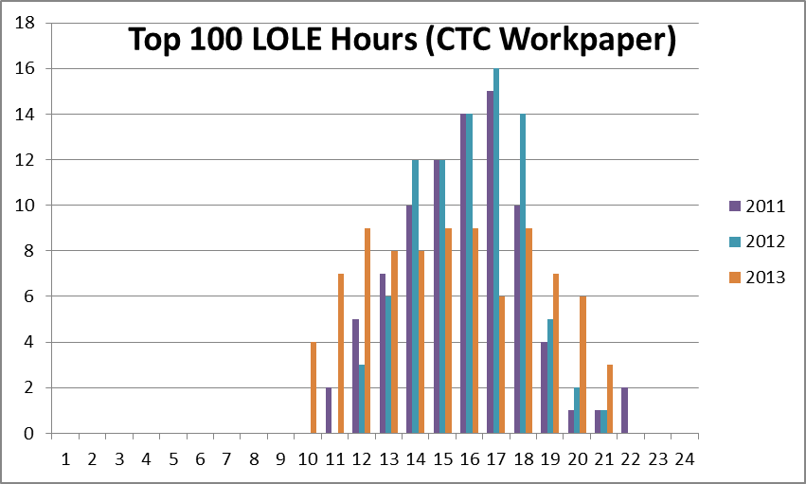

- Re: SDGE-3, SDG&E explained that it used the Ventyx Planning and Risk model to develop relative loss of load expectation/distribution for the San Diego Greater Reliability and San Diego sub-area. Chart RBA-11 showed the flatter distribution of LOLE and a spikier distribution for San Diego greater reliability area.
  - How are the LOLE analyses used to support SDG&E’s determination of TOU period definition?
  - How does the new TOU period definition address the subarea LOLE results?

- Re: SDGE-3, SDG&E explained that “choosing TOU period definition is to group together hours with similar energy costs” (p.RBA-8).
In assessing the TOU period definition, why does SDG&E choose to use DLAP data to review the energy price trend without taking into account the hourly capacity costs?

- It appears that SDG&E uses a Top 100 Hours LOLE analysis to allocate generation capacity costs, based on both the San Diego Greater Reliability Area and the San Diego sub-area.
  - How did SDG&E choose to weight the data, i.e. what method was employed, and why?

END OF REQUEST

CPUC Decision D.14-06-053 “Pio Pico Energy Power Plant Licensing Case,” http://www.energy.ca.gov/sitingcases/piopico/index.html
D.15-05-051 & D.15-11-024

