QUESTION 19.1:

  - Regarding SoCalGas’ response to SCGC-16, Question 16.2.1, please state how much of the $2.4 million is associated with “the Adelanto to Moreno pipeline.”

RESPONSE 19.1:

$0.8 million of the $2.4 million is associated with the Adelanto to Moreno pipeline.

QUESTION 19.2:

  - Regarding SoCalGas’ response to SCGC-16, Question 16.2.3:
19.2.1 Does this statement mean that the historical O&M costs for the current compressor station amount to $60,000 per year?
    - What year(s) is this figure based upon?
    - Why does the current compressor station require $60,000 per in O&M if the “current station does not normally operate” according to the response to Q.16.2.11.

RESPONSE 19.2:

19.2.1. Yes, on average. See 19.2.2.

19.2.2. The $60,000 was calculated by averaging the last 5 years of historical O&M costs incurred at the facility.

19.2.3. The current station is maintained to be operational and ready to run when required. This includes facility and equipment maintenance along with equipment emission testing required by the local air quality management district to be in compliance with permit conditions.

QUESTION 19.3:

19.3 Regarding SoCalGas’ response to SCGC-16, Question 16.2.11, which states that the current station does not normally operate:
19.3.1 Please provide the annual load factor for the current compressor station over the past ten years.
19.3.2 Is the current compressor station currently operational?
19.3.3 If the answer to the previous question is “yes,” can the current compressor station be used to increase the flow of gas south across Lines 4000/4002?
19.3.3.1 What is the range in the increased amounts of gas that could be flown south across Lines 4000/4002?
19.3.3.2 What is the range in the increase amounts of gas that could flow through Chino to Moreno assuming higher volumes of gas on Lines 4000/4002?
19.3.4 If the answer to question 19.1.3 is “no,” please explain why the current compressor if operational cannot be used to increase the flow of gas south across Lines 4000/4002.
RESPONSE 19.3:

19.3.1 For the past ten years the station has been available, however it has only run for quarterly testing (which is unloaded) and emissions testing (every 3 years, loaded). The load factor would be zero.

19.3.2 Yes.

19.3.3 No. The Adelanto compressor station can be used to transport supplies from the Wheeler Ridge Zone and from the Honor Rancho storage field to Lines 4000 and 4002; however, it does not “increase” the flow of gas in those pipelines. A pipeline’s capacity is a determined by its diameter and operating pressures.

19.3.3.1 Please refer to Response 19.3.3 of this data request.

19.3.3.2 Please refer to Response 19.3.3 of this data request.

QUESTION 19.4:

19.4 Regarding SoCalGas’ response to SCGC-16, Question 16.4:
19.4.1 Please update Table 1 to include information for the period September 2014 through March 2015.
19.4.2 Please provide workpapers for the updated figures.

RESPONSE 19.4:

Costs of Southern System Support Post Transfer to Operator ($MM)
 | Purchases  Mdth | SRMA Costs | IT BTS Ehrenberg Discounts | Total Costs
Sept 2009-Aug 2010 | 11,166* | $2.2 | $0 | $2.2*
Sept 2010-Aug 2011 | 1,045 | $3.8 | $0 | $3.8
Sept 2011-Aug 2012 | 6,858 | $2.2 | $6.9 | $9.1
Sept 2012- Aug 2013 | 19,320 | $7.9 | $12.1 | $20.0
Sept 2013- Aug 2014 | 36,946** | $12.9 | $3.0 | $15.9**
Sept 2014- Mar 2015 | 31,010** | $4.0 | $0 | $4.0**
*96% of these supplies were baseload winter supplies approved in G-3435.
** Includes baseload winter supplies approved in G-3487.

QUESTION 19.5:

19.5 Regarding SoCalGas’ response to SCGC-16, Question 16.7:
19.5.1 Please update Figure 3 to include information for January 2015 – March 2015.
19.5.2 Please provide workpapers.

RESPONSE 19.5:

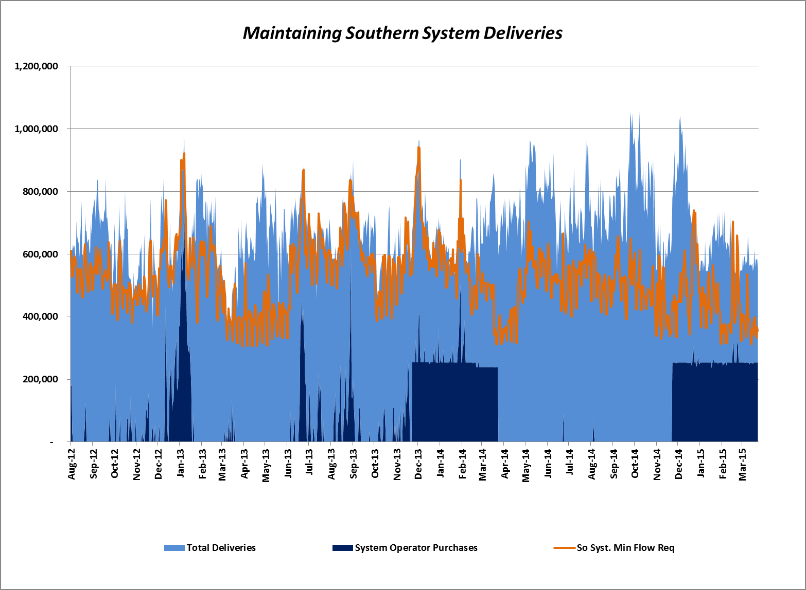

QUESTION 19.6:

  - Regarding SoCalGas’ response to SCGC-16, Question 16.11:
    - Please provide a working Excel spreadsheet that provides a calculation of the initial AFUDC rate used in the revenue requirement model.
    - Please state the actual values that SoCalGas has used in its AFUDC calculation for ROE, cost of debt, cost of preferred stock, and capital structure in each of the years (2014-2019) that SoCalGas expects to earn AFUDC for the project.

RESPONSE 19.6:

19.6.1
As stated in Response SCGC-16, Q.16.11, SoCalGas uses its current authorized Rate of Return (“ROR”) as a reasonable proxy for estimating AFUDC applied to construction work in progress in the revenue requirement model. Other than the authorized ROR, there is no separate forecast of debt and equity in developing AFUDC rates for the construction period.

19.6.2
The cost components presented in Mr. Yee’s Updated Direct Testimony and used to calculate the North-South Project’s revenue requirement, including AFUDC, are for illustrative purposes only. No actual AFUDC data is captured in the revenue requirement shown in Mr. Yee’s Updated Direct Testimony. See Response 19.6.1.

QUESTION 19.7:

  - Regarding SoCalGas’ response to SCGC-16, Question 16.12.5.5, is it correct to say that SoCalGas would “gross up” the $7.8 million actual revenue requirement in the second example to $15.6 million annual equivalent revenue requirement so that SoCalGas could then divide that annual equivalent revenue requirement by an annual throughput figure?

RESPONSE 19.7:

Yes.

