QUESTION 16.1:

16.1. With respect to SoCalGas’ response to SCGC-15, Q.15.4, Mr. Buczkowski states in his updated testimony at page 16 that “The cost estimate includes office space for the project team, including company personnel and key consultants” yet the response to SCGC-15, Q.15.4.1 states that “These expenses will be incurred by back office employees and will not be capitalized.”

16.1.1. Please describe the number of employees that SoCalGas expects to house in the office space.

16.1.2. Please describe the full range of employment activities that SoCalGas expects will occur in the office space during the project period.

16.1.3. Does SoCalGas expect that the “project team” would be housed in the office space?

16.1.4. If the answer to the previous question is “yes,” please explain why the cost of office space housing the “project team” would not fall into (10) “‘Rents’ includes amounts paid for the use of construction quarters and office space occupied by construction forces and amounts properly includible in construction costs for such facilities jointly used” at “3. Components of construction cost” under the Gas Plant Instructions at as defined by the FERC’s Uniform System of Accounts for gas utilities?

16.1.5. To the extent that “back office” personnel are housed in the office space, why doesn’t the cost of the “office space and other office related costs” fall into (12) “‘General administration capitalized’ [which] includes the portion of the pay and expenses of the general officers and administrative and general expenses applicable to construction work” at “3. Components of construction cost” under the Gas Plant Instructions at as defined by the FERC’s Uniform System of Accounts for gas utilities?

RESPONSE 16.1:

16.1.1 SoCalGas expects a range of 10-20 employees to be housed in the office space over the duration of the project.

16.1.2 The employment activities expected to occur in the office space during the duration of the project include: Engineering & Design, Environmental, Procurement, Project Controls, Project Management, Public Relations, Right-of-Way and Construction Management prior to start of construction.

16.1.3 Yes.

16.1.4 While some of the SoCalGas “project team” will be housed in the office space, a portion of the team will be located on or near the construction site in temporary field offices or trailers. The cost for temporary field offices or trailers to support construction are planned in the Construction Cost Estimates and capitalized.

16.1.5 As stated in Response to SCGC 15.4.1, these costs are not considered to be capital costs under the Sempra Energy Utilities’ Capitalization Policy. Furthermore, in cases where it is not clear either by the FERC’s Uniform System of Accounts or by the Sempra Energy Utilities’ internal policies whether a particular expenditure should be capitalized or treated as O&M, SoCalGas adopts a conservative approach and treats the expenditure as O&M, which results in an overall lower revenue requirement, as compared to capitalizing the expenditure.

QUESTION 16.2:

16.2. With respect to SoCalGas’ response to SCGC-15, Q.15.5:
16.2.1. Response 15.5.2 states that “the incremental O&M costs that SoCalGas projects that will incur specifically from the operation of the North-South Project is approximately $5.0 million per year,” which has been reduced to $2.4 million per Mr. Buczkowski’s updated testimony at p.17. Does the $2.4 million correspond to entirely new expenses that are associated solely with the new compressor station, that is, are truly incremental to the project?
16.2.2. If the answer to the previous question is “no,” please describe what costs are included in the $2.4 million that correspond to the operations of existing equipment.
16.2.3. Please breakdown the $60,000 per year in historic O&M costs stated in the response to Q.15.5.2 by the same categories that are shown on p.17 of Mr. Buczkowski’s updated testimony.
16.2.4. If the $60,000 per year figure does not include the cost of emissions fees that would be owed if the North-South Project were not completed, please state how much SoCalGas would owe for emissions fees if the existing Adelanto compression facilities were not retired.
16.2.5. Please state the size and age of the existing compression facilities at Adelanto.
16.2.6. Does the current compressor station have permanent staff located on site?
16.2.7. If the answer to the previous question is “yes,” please state how many persons are currently located on site.
16.2.8. Will the proposed new compressor station have permanent staff located on site?
16.2.9. If the answer to the previous question is “yes,” please state how many persons would be located at the site.
16.2.10. How did SoCalGas determine that a 30% load factor would be an appropriate basis for estimating the costs of allowances at the proposed Adelanto compressor?

    - What is the load factor currently experienced at the Adelanto compressor?

RESPONSE 16.2:

16.2.1. The $ 2.4 million does not correspond entirely with the Adelanto Compressor Station. A portion of the costs are associated with the Adelanto to Moreno pipeline. The $2.4 million is incremental to SoCalGas current O&M costs.

16.2.2. See Response to SCGC 16.2.1.

16.2.3. The Adelanto compressor station historical O&M costs would fall exclusively into
the Compressor Station category of Table 7 on page 17.

16.2.4. The $60,000 per year figure does not include emission fees as there were no emission fees the last five years. Future emission fees for the existing equipment at Adelanto compressor station are projected to be zero.

16.2.5. The size of the existing compression facilities at Adelanto is 220,000 sq.ft. (5 acres), and the compressor station was completed in 1973. The LM-1500 turbine powering the compressor facilities is rated at 10,000 HP.

16.2.6. No.

16.2.7. N/A

16.2.8. No.

16.2.9. N/A

16.2.10. By “allowances”, we assume SCGC is referring to greenhouse gas emission fees. The proposed Adelanto Compressor station utilization/load factor used in the calculation of greenhouse emission fees is based on a preliminary flow scenario being used as part of the evaluation of turbine compressor configuration options for Adelanto Compressor Station. The approximately 30% load factor is calculated by dividing the annual hours of operation by total potential hours of operation (number of turbines * 8760 hours per year). The load factors in evaluations ranged from 25% to 33%. Preliminary flow scenario:

Flow Rate  MMSCFD | Operating Pressures |  | Expected Operating  %
Flow Rate  MMSCFD | Suction | Discharge | Expected Operating  %
Flow Rate  MMSCFD | PSIG | PSIG | Expected Operating  %
75 | 464 | 646 | 1
100 | 464 | 646 | 8
200 | 464 | 656 | 8
300 | 464 | 676 | 5
400 | 464 | 696 | 19
500 | 464 | 726 | 39
600 | 464 | 756 | 15
700 | 464 | 786 | 5
800 | 464 | 826 | 1

16.2.11. Zero. The current station does not normally operate.

QUESTION 16.3:

  - With respect to the Answers to Questions in Administrative Law Judge’s Ruling, filed by SoCalGas on February 2, 2015, at page 21 SoCalGas states: “Line 3602 would…allow the repurposing of most of Line 1600 from transmission to distribution….”

    - Would the portions of Line 1600 that SoCalGas characterizes as being repurposed to distribution be pressurized at levels below the threshold established by CFR 49 Section 192 (Part 192) as requiring pressure testing?
    - Which segments of Line 1600 would be repurposed from transmission to distribution?

RESPONSE 16.3:

SoCalGas and SDG&E are still evaluating how to proceed with the possible repurposing of portions of Line 1600. Under the proposal outlined in our Answers to Questions, the pressure in portions of Line 1600 would be reduced from transmission to distribution pressure, which would bring those portions of Line 1600 below the threshold required for pressure testing. SoCalGas and SDG&E are still evaluating which portions of Line 1600 could be repurposed in this manner, but have not made a firm decision yet. The portions of Line 1600 that could be repurposed in this manner as a result of the construction of Line 3602 will be described in our upcoming Line 3602 application.

QUESTION 16.4:

Please update Table 1 of Ms. Marelli’s Updated Testimony to include the period September 2013 – August 2014. Please provide all workpapers.

RESPONSE 16.4:

Costs of Southern System Support Post Transfer to Operator ($MM)
 | Purchases  Mdth | SRMA Costs | IT BTS Ehrenberg Discounts | Total Costs
Sept 2009-Aug 2010 | 11,166* | $2.2 | 0 | $2.2*
Sept 2010-Aug 2011 | 1,045 | $3.8 | 0 | $3.8
Sept 2011-Aug 2012 | 6,858 | $2.2 | $6.9 | $9.1
Sept 2012- Aug 2013 | 19,320 | $7.9 | $12.1 | $20.0
Sept 2013- Aug 2014 | 36,946** | $12.9** | $3.0 | $15.9**
*96% of these supplies were baseload winter supplies authorized in G-3435.
** Includes baseload winter supplies in Advice No. 4690, Attachment A and authorized in G-3487.

QUESTION 16.5:

Please update Figure 1 of Ms. Marelli’s Updated testimony to provide the 2014 average southern system minimum requirement and 2014 average customer deliveries to the southern system. Please provide all workpapers.

RESPONSE 16.5:

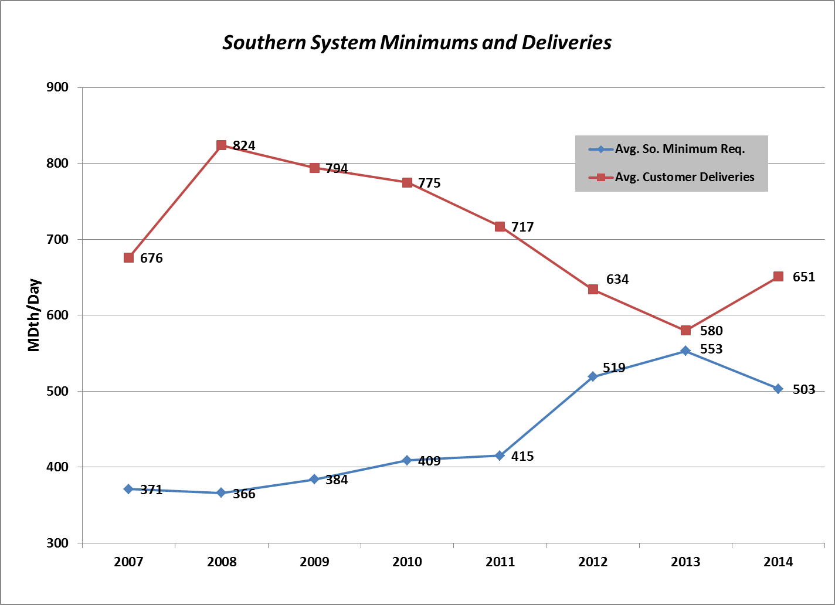

QUESTION 16.6:

Please update Figure 2 of Ms. Marelli’s Updated testimony to provide the monthly historical EG demand on the Southern System. Please provide all workpapers.

RESPONSE 16.6:

Historical EG Demand on Southern System
(SONGS Outage began in January 2012)
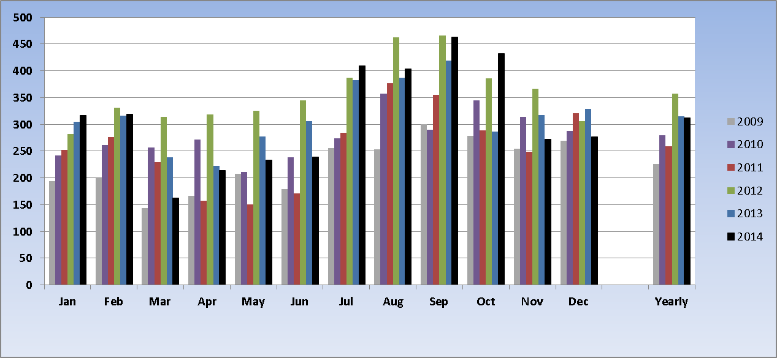

QUESTION 16.7:

Please update Figure 3 of Ms. Marelli’s Updated testimony to provide daily total deliveries (cycle 5), CEH purchases, and daily southern system minimum (cycle 4) for 2014. Please provide all workpapers.

RESPONSE 16.7:

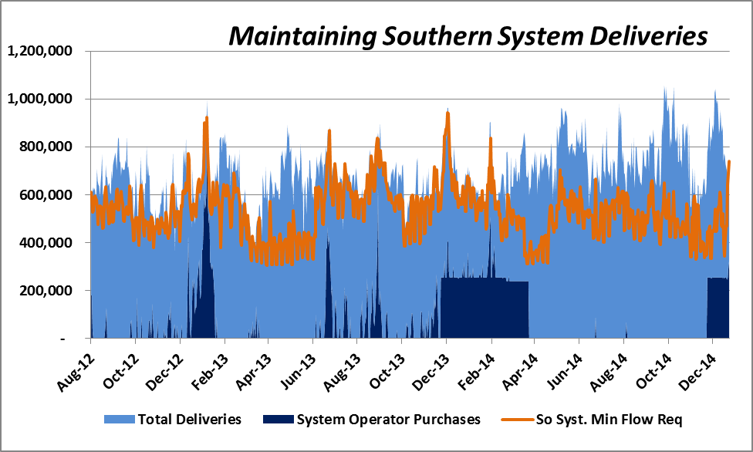

See file provided in Response to SCGC 16.5.

QUESTION 16.8:

16.8. With respect to Table 2 on page 5 of David Buczkowski’s updated testimony:

16.8.1. In percentage terms, how much uncertainty is inherent in SoCalGas’ cost estimates as they are shown in Table 2?

16.8.2. How would you characterize the estimate in Table 2 in terms of the Advancement of Cost Engineering (AACE) classes of estimates?

RESPONSE 16.8:

16.8.1. As stated at page 4 of David Buczkowski’s Updated Direct Testimony:

As a result of a more mature project scope definition, degree of completion of deliverables, and execution plan development, our estimate is within a Class 3 range of accuracy as defined by the Association for the Advancement of Cost Engineers International (AACE). A Class 3 estimate as applied for the Building and General Construction Industries, most relevant to pipeline construction, is defined as:
- Having a maturity level of project definition deliverables between 10% and 40%
- An end usage of design development, budget authorization, feasibility
- Based on a methodology of semi-detailed unit costs with assembly level line items
- An expected accuracy range of -5% to -15% and +10% to +20%

The only variance between the Class 3 estimate above and as applied for the
Process Industries, most applicable to compressor station construction, is a higher
range of expected accuracy of +30%.

16.8.2. See Response to SCGC 16.8.1.

QUESTION 16.9:

Please provide the workpapers for Mr. Yee’s updated testimony in Excel format.

RESPONSE 16.9:

QUESTION 16.10:

Please provide the workpapers for Mr. Bonnett’s updated testimony in Excel format.

RESPONSE 16.10:

QUESTION 16.11:

Please show how SoCalGas calculated the AFUDC rate that it proposes to use in capitalizing the North-South Project. The response should refer directly to the formula contained in (17) “Allowance for funds used during construction” at “3. Components of construction cost” under the Gas Plant Instructions at as defined by the FERC’s Uniform System of Accounts for gas utilities and should identify each of the rates that SoCalGas used in completing the AFUDC calculation. SoCalGas should also cite to authority in justifying each of the rates used in the AFUDC formula.

RESPONSE 16.11:

Consistent with prior SoCalGas proceedings before the CPUC, including D.13-05-010, SoCalGas uses its current authorized Rate of Return (“ROR”) of 8.02% as a reasonable proxy for estimating AFUDC applied to construction work in progress. Historically, for various proceedings, SoCalGas uses its authorized ROR for forecasting purposes which reasonably approximates its actual AFUDC rates. This is the methodology used to illustrate the forecasted AFUDC on the North-South Project. On an actual basis, SoCalGas applies an AFUDC rate that is computed in conformance with the formula prescribed by the FERC Uniform System of Accounts. SoCalGas’ actual AFUDC rate is derived by taking its capital structure at the time of the calculations and weighting its actual capital structure by the authorized return on equity, actual costs of debt, and authorized preferred stock costs as adopted in D.12-12-034.

QUESTION 16.12:

16.12. Referring to the workpapers of Gary Yee provided in response to SCGC- 01, Q.1.1, at tab “Escalation”:

16.12.1. Please explain why there is an escalation factor for capital shown for each year through 2039.

16.12.2. Does the witness expect that there would be a need to complete capital repair and maintenance on the facility during each year of its life?

16.12.3. Does the witness use the capital escalation rate in calculating the revenue requirement in years following 2019?

16.12.4. If the answer to the previous question is “yes,” please identify which years that capital escalation rate is used in calculating revenue requirement and describe in what way the escalation factor is used.

16.12.5. Regarding Mr. Yee’s testimony at page 4 that states: “SoCalGas will file an advice letter within 60 days after the assets are placed into service to incorporate the actual revenue requirement in rates on the first day of the next month following advice letter approval.”

16.12.5.1. Referring to Table 5 of Mr Yee’s testimony, is SoCalGas proposing that the revenue requirement shown for 2014, 2018, and 2019 be recovered in rates prior to the completion of the North-South Project at the end of 2019?

16.12.5.2. If the answer to the previous question is “yes,” do these amounts correspond to portions of the project that are completed prior to the end of 2019?

16.12.5.3. Please show how the revenue requirement would be placed in rates for any situation where the project was to be completed on a date other than December 31.

16.12.5.4. In the situation where the project was completed mid-year, how the partial year revenue requirement would be calculated? Please show an exemplary calculation.

16.12.5.5. In the situation where the project was completed mid-year, how would rates be calculated based on the partial year revenue requirement? Please show an exemplary calculation.

RESPONSE 16.12:

16.12.1
As stated in Mr. Buczkowski’s Updated Direct Testimony on page 5, the capital cost estimates provided are initially stated in 2014 direct dollars, and these capital costs continue into 2039. The application of escalation factors to these direct costs is required to state costs in fully loaded and escalated nominal dollars.

16.12.2
No, SoCalGas does not expect to have any annual capital repair and maintenance costs after the project goes into service in 2019. To the extent that SoCalGas encounters unforeseen capital repair and maintenance costs after 2019, SoCalGas will determine what warranties are in effect, and whether costs can be borne by the vendor. If SoCalGas incurs unforeseen capital repair and maintenance costs after 2019, SoCalGas proposes to record these costs in the North-South Infrastructure Memorandum Account (NSIMA) for recovery in rates until they are addressed in SoCalGas’ next GRC or other applicable proceeding. This scenario is not reflected in the revenue requirement illustrated in Mr. Yee’s Updated Direct Testimony. However, as stated in Mr. Buczkowski’s workpapers on page WP-3, the capital costs extending beyond the in-service date (the period 2020-2039) are related to post-construction environmental monitoring. The revenue requirement associated with these post-construction environmental monitoring costs are included in the revenue requirement illustrated in Mr. Yee’s Updated Direct Testimony.

Additionally, as stated in Mr. Buczkowski’s Updated Direct Testimony on page 17, there will be incremental ongoing post-construction O&M costs after the assets are placed into service. These costs are excluded from the revenue requirement illustrated in Mr. Yee’s Updated Direct Testimony, although as discussed in the Updated Direct Testimony of Mr. Ahmed, SoCalGas proposes to record these costs in the NSIMA for recovery in rates until they are addressed in SoCalGas’ next GRC or other applicable proceeding.

16.12.3
Yes.

16.12.4
As shown in Mr. Yee’s workpapers on page 4-1, the capital escalation rates as published in the IHS Global Insight 2nd Quarter 2014 Utility Cost Forecast differ depending on the year of the future cash flow. The capital escalation rates used for the years 2020-2039 range from 2.07% to 2.60%. These rates are converted to corresponding escalation factors with 2014 as the base year. As a result of the conversion, the escalation factors for years 2020-2039 range from 1.1530 to 1.7231, which are applied to the expected 2020-2039 capital cash flows and applicable overheads. Fully loaded and escalated capital costs are then captured in the associated revenue requirement and recovered through depreciation expense.

16.12.5.1
No, there will be no revenue requirement recovery in rates until after the project is placed into service at the end of 2019. The revenue requirement portrayed in Table 5 for years 2014-2019 relate to the estimated O&M that will occur during the construction phase, as discussed in Mr. Buczkowski’s Updated Direct Testimony on page 16. As stated in Mr. Ahmed’s Updated Direct Testimony on page 1, SoCalGas proposes that the NSIMA will record actual O&M incurred to complete the project. Upon authorization to recover the NSIMA balance from customers, SoCalGas will amortize the NSIMA in rates in connection with its annual regulatory account balance update filings for rates.

To the extent that a segment of the Project is completed and placed into service prior to the completion of all other segments of the Project, SoCalGas proposes to record the capital-related costs (i.e., depreciation, taxes, and return) of that segment in the NSIMA. Upon authorization to recover the NSIMA balance from customers, SoCalGas will amortize the NSIMA in rates in connection with its annual regulatory account balance update filings for rates. This scenario is not reflected in the revenue requirement illustrated in Mr. Yee’s Updated Direct Testimony.

16.12.5.2
See Response to SCGC 16.12.5.1

16.12.5.3
As stated in Mr. Bonnett’s Updated Direct Testimony, if the revenue requirement is placed into rates on a date other than January 1, the first year’s revenue requirement will be adjusted to ensure it is fully collected over the remaining months of the year. See example below in Response SCGC 16.12.5.5.

16.12.5.4
Actual revenue requirement would be calculated for the remaining months of the year. For example, assume a project with fully loaded and escalated capital costs of $100 million dollars, going into service December 31, 2019. The revenue requirement for 2019 would be $0 and the revenue requirement for 2020 would be as follows:

Now assume the project goes into service June 30, 2019 instead of December 31, 2019. Then the revenue requirement for 2019 would be as follows:

16.12.5.5
See Responses to SCGC 16.12.5.3 and 16.12.5.4. Using the same illustrative example from 16.12.5.4, the new Backbone Transmission Service (BTS) rate capturing the project’s mid-year in-service date would be calculated as follows:

 | Current BTS Revenue Requirement | Example Project Revenue Requirement | Total BTS Revenue Requirement | Total BTS Rate  $/dth/day
2019 | A | $15.6 million* | A + $15.6 million | (A + $15.6 million) / (Throughput*365)
*2019 revenue requirement of $7.8 million is grossed-up to $15.6 million in order to recover the amount over 6 months due to the assumed in-service date of June 30, 2019.

This format can also be found at Table 1 of Mr. Bonnett’s Updated Direct Testimony and page 2 of 28 of Mr. Bonnett’s workpapers.

QUESTION 16.13:

16.13. Referring to the workpapers of Gary Yee provided in response to SCGC- 01, Q.1.1, at tab “Rev Req”:

16.13.1. What are the depreciation rates assumed in completing the calculation?

16.13.2. What are the negative salvage rates assumed in completing the calculation?

RESPONSE 16.13:

16.13.1
The depreciation expense of the illustrated revenue requirement is based on the assets’ FERC Account-specific useful lives and salvage rates that are currently in place and authorized by D.13-05-010. SoCalGas uses the straight-line remaining life method to calculate depreciation expense on the North-South Project assets.
Project Component | FERC Account | Book Life | Salvage
Adelanto-Moreno Pipeline | 367 – Transmission Mains | 57 Years | -30%
Adelanto Compressor | 368 – Transmission Compressor Station Equipment | 43 Years | -10%

16.13.2
See Response to SCGC 16.13.1.

TY2012 General Rate Case of SDG&E and SoCalGas.
D.12-12-034 (TY2013 Cost of Capital for Major Utilities), Ordering Paragraph 3, p53.
Title 18, Code of Federal Regulations, Chapter 1, Part 201, Gas Plan Instruction 3(A)17.
Updated Direct Testimony of Jason Bonnett, p. 2
TY2012 General Rate Case of SDG&E and SoCalGas.

