Draft Small Customer Technology Deployment (SCTD) Load Impact Report

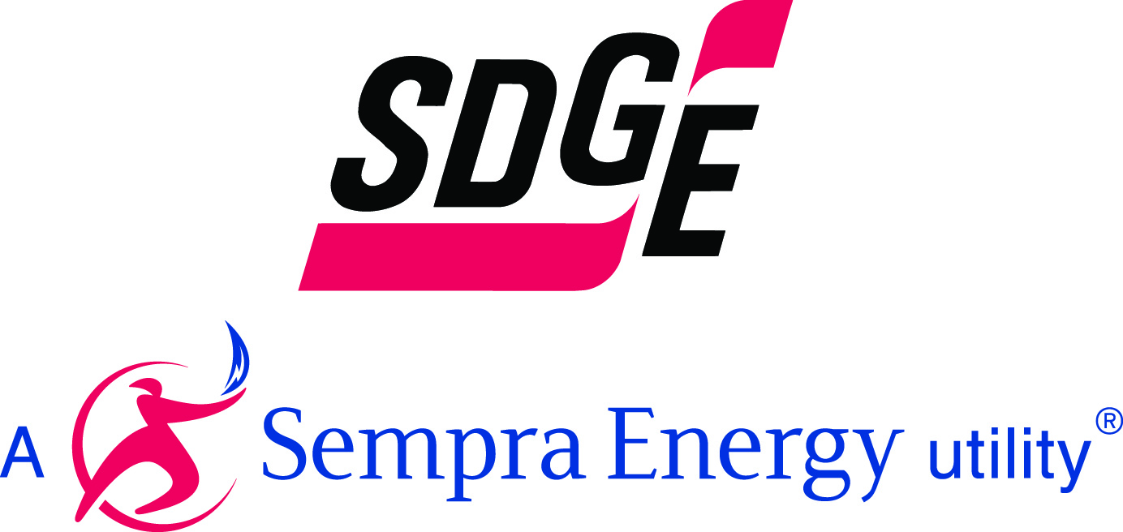

April 1st 2013

I. Program Description

SDG&E’s Small Customer Technology Deployment (SCTD) Program will offer
DR enabling technologies at no cost to SDG&E residential customers enrolled in PTR or the residential peak shift at home rate. At present, SDG&E plans to deploy meter connected programmable communicating thermostats (PCT) that can be controlled by SDG&E and other enabling technologies are under consideration. SDG&E plans to market the program through contractor driven energy efficiency programs such as the Energy Upgrade CA - Whole House program (EUC-WHP), MIDI, HVAC tune up and the energy savings assistance program. In addition SDG&E plans to market the program directly to high usage customers who have been identified as having significant air-conditioning useage based on their Smart Meter data. SCTD customers receive a PCT at no cost and will earn an incentive of $1.25 for reducing their energy usage during PTR events.

II. Forecast Summary
The SCTD forecast accounts for load impacts from meter connected utility controlled PCT. Although pool pumps controls and Wi-Fi connected thermostats may be included in the SCTD program in the future, they are not included in this forecast since it it is uncertain at this time if they will be included. Table 1 below contains the forecast for 2013-2014 for the SCTD program. The details of the program forecast are presented in section III of this report.

Table1: Small Customer Technology Deployment forecast (MW)
Program | Year | Weather | Jan | Feb | Mar | Apr | May | Jun | Jul | Aug | Sep | Oct | Nov | Dec
SCTD | 2013 | 1in 2 | 0 | 0 | 0 | 0 | 0 | 0 | .08 | .18 | .32 | .42 | 0 | 0
SCTD | 2014 | 1in 2 | 0 | 0 | 0 | 0 | .85 | .86 | 1.03 | 1.27 | 1.59 | 1.67 | 0 | 0

- Forecast Details
Previous SDG&E Smart Thermostat studies and Summer Saver studies have shown that one factor that decreases the load impacts and cost-effectiveness of these programs is that customers who never or seldom use their air-conditioners join the program and receive an incentive. The SCTD program improves this issue in two ways. One way this issue is improved is that no flat incentive is provided. Only a PTR incentive is provided and a PTR incentive is only paid if a customer’s usage is lower than their customer reference level. The other improvement this program makes is that Smart Meter data will be used to market the program to customers likely to have high on-peak air-conditioner usage. Hourly Smart Meter whole house data can be used to identify customers who are likely to use their air-conditioner on-peak. In order to estimate the effects that targeting customers using hourly whole house smart meter data will have on the load impacts Freeman Sullivan and Company (“FSC”) conducted analysis on behalf of SDG&E using the load data from the load research air-conditioning sample. This sample is a randomly selected sample of customers with central air-conditioning. These customers have a meter both on their home and on their air-conditioner. Using the whole house data only, FSC ran a regression model and identified the top 35% of customer most likely to have high on-peak air-conditioning usage. The air-conditioning usage of these top customers was then used to create the reference load for the residential Programmable Communicating Thermostat (“PCT”) forecast. SDG&E also plans to offer PCT to customers who enroll in the Energy Upgrade California program. SDG&E expects to install 422 PCTs by August of 2013 and 2954 PCTs by August of 2014.
Two sets of estimates are provided for the SDTD program one for the entire load reduction achieved by the program and the other for the load reduction achieved incremental to PTR. The percentage air-conditioning load reduction used for the forecast comes from the SDG&E Smart Thermostat 2007 evaluation. The incremental load reduction was calculated by comparing the smart thermostat load reduction to the load reduction of PTR opt-in alert customers.

