
Economic Sciences Corporation
1516 LeRoy Avenue
Berkeley, CA 94708
TEL (510) 841-6869 e-mail esc@econsci.com
FAX (510) 644-1943 www.econsci.com

March 23, 2007

Ms. Lisa Browy
San Diego Gas & Electric Company
8306 Century Park Court
San Diego, CA 92123

Re: BOMA Data Request 1 – SDG&E 2008 GRC Ph-2 (A.07-01-047)

Dear Ms. Browy:

On behalf of the Building Owners and Managers Association of San Diego and the Building Owners and Managers Association of California, I hereby make a formal data request in connection with SDG&E’s 2008 GRC Phase 2 Proceeding A.07-01-047. The data requested includes the following:

1) All current workpapers and spreadsheet models related to SDG&E’s GRC Ph-2 Electric Rate Design Application and Testimony that support SDG&E’s calculation of marginal costs, revenue allocation, rate design, and Sales and Load forecasts. I understand that these materials are available on CD’s and/or on hard copy. To the extent that CD’s are all inclusive the CD version would be preferred.

Since two persons at Economic Sciences Corporation ( Helen Chin and me), working at different locations, will be analyzing these data on behalf of BOMA San Diego and BOMA Cal, I request that we receive two copies of the data that will be provided. The location information for the two viewing parties is as follows:

Bill F. Roberts Helen Chin
President Vice President
Economic Sciences Corporation Economic Sciences Corporation
1516 LeRoy Avenue 425 Noriega Street
Berkeley, CA 94708 San Francisco, CA 94122
Tel (510) 841-6869, fax (510) 644 1943 Tel (415) 566-2384
bill@econsci.com helen@econsci.net

Both Helen Chin and I will sign any required Nondisclosure Agreements and the Protective Orders that may be appropriate for access to the data requested.

Thank you for your prompt reply.

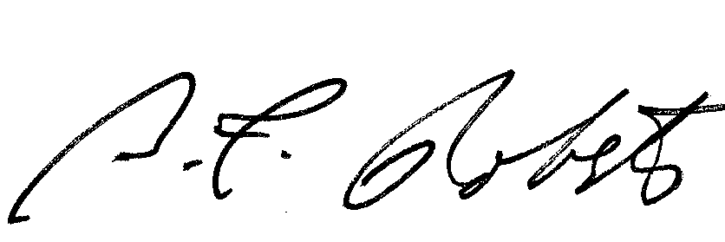
Sincerely,
Bill F. Roberts
President

