**SDG&E® RESIDENTIAL AND SMALL BUSINESS CONTENT PACKAGE | AUGUST 2024**

As a trusted community member, we thank you for sharing our content and digital assets with your audiences – including residents, customers and employees – to help amplify our key messages in your email communications, websites or newsletters.

**Best practices for using our content, social media posts and images**

1. **IMAGES**

Choose images that are relevant for your audience and feel free to mix and match what we provide at the end of this content package. For alternate images, [***Unsplash.com***](https://unsplash.com/) and [***Canva.com***](https://www.canva.com/photos/free/) offer free images that you can download.

1. **SDG&E logo**

You’re welcome to mention our name but, due to legal requirements, please do not use our logo in any marketing materials that you create. Please only use the SDG&E logo if we provide it to you in this package or it’s publicly available online like a social post or video. You can also retweet our public posts which you’ll find on [***facebook.com/sdge***](https://www.facebook.com/search/top?q=san%20diego%20gas%20%26%20electric) and [***twitter.com/sdge***](https://twitter.com/sdge).

1. **Videos**

We have a library of videos you can share in your communications and SOCIAL POSTS when you visit [[***youtube.com/c/SanDiegoGasElectric/videos***](https://www.youtube.com/c/SanDiegoGasElectric/videos)](https://www.youtube.com/c/SanDiegoGasElectric/videos). If you’d like to sort our videos by topic, visit [***youtube.com/c/SanDiegoGasElectric***](https://www.youtube.com/c/SanDiegoGasElectric). Some videos are in Spanish. You’ll see some on TV, too!

**Follow us**

Find us on [**Facebook**](https://www.facebook.com/SanDiegoGasandElectric)**,** [**Instagram**](https://www.instagram.com/sdge)**,** [**Twitter**](https://twitter.com/SDGE)**,** [**YouTube**](https://www.youtube.com/sandiegogaselectric)and[**LinkedIn**](http://linkedin.com/company/sdge). When sharing our digital assets and content, feel free to tag SDG&E’s social media and direct your audience to [***sdge.com***](https://www.sdge.com).

**This month’s topics:** My Energy Center, Public Safety Power Shutoffs, energy-saving tips for residential and business customers, metallic balloon safety, Flex Alerts, Cool Zones

**Article: My energy center is here!**

SDG&E’s My Account has transitioned to My Energy Center. This safe and secure portal makes it easy to manage your energy usage and costs.

While the My Energy Center portal is an upgrade, rest assured that the security and convenient features and services you know from My Account remain intact – like viewing and paying your bill, Auto Pay, paperless billing and scheduling services online or on the app.

Working with the region’s two Community Choice Aggregators (CCAs) – Clean Energy Alliance (CEA) and San Diego Community Power (SDCP) – My Energy Center features a new level of transparency to help you better understand your bill and manage your energy use.

My Energy Center customer benefits include:

* User-friendly breakdown of charges including your energy delivery from SDG&E and your electric usage, whether you receive service from a CCA or SDG&E.
* Greater insights into your gas and electricity usage patterns to help you find ways to save energy and lower your bill.
* Ease of access through the SDGE.com, SDCP and CEA websites, or directly at [***MyEnergyCenter.com***](https://myenergycenter.com/).

If you had previously been enrolled in My Account, you can simply log in with your existing username and password. If you already downloaded the SDG&E mobile app, it will automatically update to the new My Energy Center app.

For more info, visit [***sdge.com/MEC***](https://www.sdge.com/my-energy-center).

**social posts: my energy center is here!**

1. SDG&E’s My Account has transitioned to My Energy Center! This new user-friendly portal makes it easier to understand your energy bill and manage your energy use in one place. Learn more at [***sdge.com/MEC***](https://www.sdge.com/my-energy-center). #SDGE #SDGEassist
2. Want to save on your energy bill? Visit [***MyEnergyCenter.com***](https://myenergycenter.com/) to view your charges, energy usage and tips to optimize your energy use. Whether you receive service from SDG&E or a Community Choice Aggregator, you may be able to save energy and money with the tools and features of My Energy Center! Learn more at [***sdge.com/MEC***](https://www.sdge.com/my-energy-center). #SDGE #SDGEassist
3. Check out the new My Energy Center! SDG&E’s My Account has transitioned to My Energy Center, keeping all the secure and convenient features you love—like viewing and paying your bill, Auto Pay, paperless billing, and scheduling services online. Log in seamlessly with your My Account username and password. Learn more at [***sdge.com/MEC***](https://www.sdge.com/my-energy-center). #SDGE #SDGEassist

**ARTICLE: DISCOVER ENERGY-SAVING TIPS FOR A COOLER SUMMER**

As temperatures rise, so does our need for air conditioning. Let’s dive into ways to help keep your home cool and your energy bills lower, along with other energy-saving tips.

1. Avoid using the oven during the hottest parts of the day. Grill or microwave meals or prepare cold dishes.

2. Unplug electronic devices when you’re not using them. They can still generate heat in standby mode.

3. If you have outdoor spaces like a patio, use umbrellas or shade sails to provide protection from the sun. It can help keep your outdoor area cooler and reduce the need for additional cooling indoors.

4. Use a programmable thermostat to automatically adjust the temperature based on your schedule. Set the A/C at a higher temperature when you’re away or asleep. Check out thermostat rebates at [***GoldenStateRebates.com***](https://goldenstaterebates.clearesult.com/browse-products).

5. Run your ceiling fan counter-clockwise when it’s hot. It creates a downdraft which makes you feel cooler.

6. Shift some chores like laundry and running the dishwasher outside of the on peak hours of 4 p.m. to 9 p.m. Save even more if you do laundry on the weekends before 2 p.m.

For more energy-saving tips, visit [***sdge.com/MyEnergy***](https://www.sdge.com/energy-management-summer). Actual savings may vary.

**SOCIAL POSTS: DISCOVER ENERGY-SAVING TIPS FOR A COOLER SUMMER**

Use any bullet above and then add: For more energy-saving tips, visit [***sdge.com/MyEnergy***](https://www.sdge.com/energy-management-summer). #sdge #SDGEassist

**article: Safety tips for using metallic balloons**

Did you know that metallic balloons have caused over 520 costly outages and 18 dangerous fire ignitions in the last five years? Metallic balloons bring smiles to picnics, parties and family gatherings. But, when left untethered outside, they may float into power lines, cause an electrical surge and blow the circuit — resulting in a power outage and even sparking an electrical fire. Keep metallic balloons indoors, but if your festivities take you outdoors, keep them securely fastened. After using a metallic balloon, dispose of it by puncturing it in several places. Find more safety tips at [***sdge.com/safety***.](https://www.sdge.com/safety/electrical-gas-safety-tips)

**social posts: Safety tips for using metallic balloons**

1. Always keep metallic balloons indoors to prevent them from floating into power lines and causing outages or fires. For more safety tips, visit [***sdge.com/safety***](https://www.sdge.com/safety/electrical-gas-safety-tips). #SDGE #SDGEassist
2. If you must take metallic balloons outside, ensure they are securely fastened to a weight to prevent them from drifting away. For more safety tips, visit [***sdge.com/safety***](https://www.sdge.com/safety/electrical-gas-safety-tips). #SDGE #SDGEassist
3. After use, puncture metallic balloons in several places before disposing of them to prevent them from becoming airborne. For more safety tips, visit [***sdge.com/safety***](https://www.sdge.com/safety/electrical-gas-safety-tips). #SDGE #SDGEassist
4. Never release metallic balloons near power lines or electrical equipment, as they can cause dangerous electrical surges. For more safety tips, visit [***sdge.com/safety***](https://www.sdge.com/safety/electrical-gas-safety-tips). #SDGE #SDGEassist

**article: Flex Alerts: Why and When They Happen**

A Flex Alert is a call for people to voluntarily conserve electricity when there’s an anticipated energy shortage, especially if the California Independent System Operator (CAISO) needs to use reserves. Reducing electricity use during a Flex Alert can prevent more severe measures, like rolling blackouts.

CAISO, which manages 80% of California’s high-voltage electric grid, can issue Flex Alerts. They typically occur in the summer from 4 p.m. to 9 p.m. when high temperatures drive up electricity use. Other triggers may include unplanned power plant outages, fires affecting transmission lines and heat storms. Alerts are usually issued a day in advance, but sudden emergencies can prompt immediate alerts.

Know when to shift energy use to support the grid by signing up for Flex Alert notifications at [***FlexAlert.org***](https://flexalert.org/)in the upper right corner.

**social posts: Flex Alerts: Why and When They Happen**

1. Keep up to date on California’s daily energy outlook and statewide Flex Alerts at [***sdge.com/Flex-Alert***](https://www.sdge.com/flex-alert). #sdge #FlexAlert #SDGEassist
2. Know when to shift energy use to support the grid by signing up for Flex Alert notifications at [***FlexAlert.org***](https://www.flexalert.org/) in the upper right corner. #sdge #FlexAlert #SDGEassist

**For Flex Alert graphics, visit** [**flexalert.org/news/logos-web-banners**](https://www.flexalert.org/news/logos-web-banners).

**article: need to beat the heat?**

Here’s a cool idea: head on over to one of San Diego County’s Cool Zones. These sites provide relief during elevated temperatures in our region to help you keep cool and save on energy costs. Learn more at [***sdge.com/CoolZones***](https://www.sdge.com/tools/summer/coolzones)*.*

**social posts: need to beat the heat?**

1. Escape the heat by visiting a free, air-conditioned location. Find one near you at [***sdge.com/CoolZones***](https://www.sdge.com/tools/summer/coolzones). #SDGE #SDGEassist
2. Stay cool and save on energy costs by visiting one of San Diego County’s Cool Zones during hot weather. Learn more at [***sdge.com/CoolZones***](https://www.sdge.com/tools/summer/coolzones). #SDGE #SDGEassist

**ARTICLE:** **SUMMER energy-saving tips for businesses**

As temperatures rise during the summer months, energy costs can rise too. However, with a few strategic adjustments, you can keep your business cool and your energy bills in check. Here are some practical energy-saving tips for businesses:

1. **Optimize Air Conditioning**: Ensure your air conditioning system is running efficiently by scheduling regular maintenance. Clean or replace filters monthly to improve airflow and reduce energy consumption. Set thermostats to a comfortable but energy-efficient temperature, ideally around 78°F when the space is occupied and higher when it’s not.
2. **Use Smart Thermostats**: Invest in smart thermostats that can be programmed to adjust temperatures based on your business hours. These devices can learn your schedule and make automatic adjustments, ensuring optimal energy use without sacrificing comfort. Check out thermostat rebates at [***GoldenStateRebates.com***](https://goldenstaterebates.clearesult.com/browse-products)***.***
3. **Utilize Fans and Ventilation**: Use ceiling fans and portable fans to circulate air and reduce the need for air conditioning. Ensure your space is well-ventilated to prevent heat buildup and improve overall comfort. Run your ceiling fan counter-clockwise when it’s hot. It creates a downdraft which makes you feel cooler.
4. **Optimize Office Layout**: Arrange workspaces to take advantage of natural light and airflow, reducing the need for artificial lighting and cooling.
5. **Install Window Film**: Apply reflective window film to reduce heat gain from the sun, keeping your space cooler and reducing the load on your air conditioning system.

These energy-saving tips may help businesses reduce their energy consumption, lower operating costs and create a more comfortable environment for employees and customers alike. Stay cool and save energy this summer!

For more energy-saving ideas, visit [***sdge.com/MyBusiness***](https://www.sdge.com/business/savings-center/business-winter-savings-safety-and-solutions). Actual savings may vary.

**SOCIAL POSTS: SUMMER energy-saving tips for businesses**

Use any of the tips above and then add:

Visit [***sdge.com/MyBusiness***](https://www.sdge.com/business/savings-center/business-winter-savings-safety-and-solutions) for more helpful energy-saving tips. #sdge #SDGEassist

**IMAGES TO MIX AND MATCH WITH ABOVE ARTICLES AND SOCIAL POSTS**

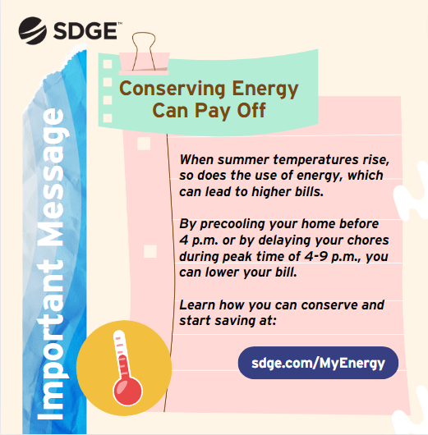

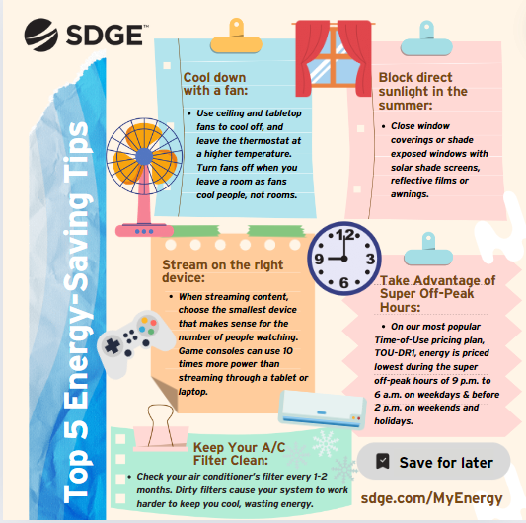











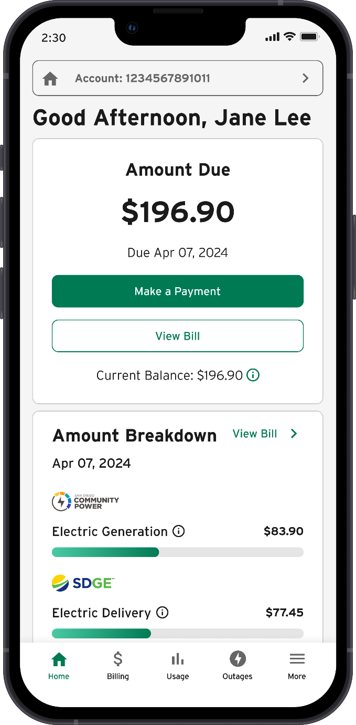

(this is an image of the new My Energy Center homepage)